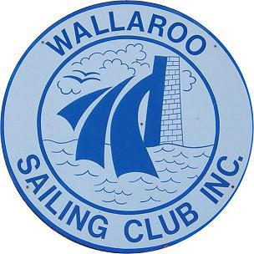
WALLAROO SAILING CLUB PROGRAMME
2022/2023 SEASON
DATE | RACE TYPE | RACE OFFICER
9th October | Opening Day  Short race | Peter Elverd
16th October | Series 1 Handicap  2 races | David Murphy
23rd October | Club Championship – 1 race  Heat 1 | Kym Flint
30th October | Series 1 Handicap  2 races | Laurent Guerrero
6th November | Club Championship – 1 race  Heat 2 | David Woodforde
13th November | Series 1 Handicap  2 races | Wayno
20th November | Series 1 Handicap  2 races | Peter Elverd
27th November | Series 1 Handicap  2 races | Samara
4th December | Stern Chaser  (Tasar State Heats at Somerton) | Peter Elverd
11th December | Series 1 Handicap  2 races | Laurent Guerrero
18th December | Series 1 Handicap  2 races | David Woodforde
8th January | Series 1 Handicap  2 races | Peter Elverd
15th January | Club Championship – 1 race  Heat 3 | Kym Flint
22nd January | Club Championship – 1 race  Heat 4 | Wayno
29th January | Stern Chaser | Kym Flint
5th February | Club Championship – 1 race  Heat 5 | David Woodforde
12th February | Series 2 Handicap  2 races | David Murphy
19th February | Club Championship – 1 race  Heat 6 | Laurent Guerrero
26th February | Series 2 Handicap  2 races | Samara
Saturday  4th March | Tasar State Heats  Wallaroo | TBA (Neville Hank or Peter Elverd)
Sunday  5th March | Tasar State Heats  No club racing | TBA (Neville Hank or Peter Elverd)
12th March | Club Championship – 1 race  Heat 7 | Kym Flint
19th March | Series 2 Handicap  2 races | David Murphy
26th March | Series 2 Handicap  2 races | Wayno
2nd April | Closing Day  Stern Chaser | Kym Flint
NOTE:
The program will change to accommodate not enough boats being available to sail championships. Swaps of races will occur.

