Gymnastics WA

Member Screening Procedure

**Date of Issue**   
**Last Reviewed**

**Controlling Body** Gymnastics WA Board

# b'ground 1. Introduction

## Gymnastics Western Australia Member Screening Procedure provides an outline for the Association and its member clubs to follow when employing or appointing staff or volunteers (paid or unpaid).

We are committed to providing a safe environment for our members, as part of this, we will screen positions of responsibility and those in child related work.

We acknowledge the valuable contribution made by our staff, members and volunteers and we encourage their active participation in providing a safe, fair and inclusive environment for all participants.

# 2. Purpose

Member Screening is a strategy adopted by Gymnastics Western Australia (GWA) to enhance the positive participatory environment for its junior and youth (18 years and under) members.

The GWA Member Screening Procedure (updated September 2017) is designed to align with current state-based legislation and ensure a best-practice approach to safeguarding children in sporting environments.

# 3. Contents

1. Introduction 1

2. Purpose 2

3. Contents 2

4. Screening Procedure 3

5. Screening Requirements 5

6. Process for Criminal Record Checks 6

7. Criminal Record Pathways 9

8. Recognising When a Child is at Risk of Abuse or Neglect 10

Attachment 1: Respond and React Process 14

Attachment 2: Categories of Child Related Work 15

Attachment 3: Renewing WWC Card Online 17

Attachment 4: Parent Volunteer Exemptions 18

Attachment 5: Record Keeping 20

Attachment 6: Uploading WWCC Details on GOL 22

# 4. Screening Procedure

Screening is vital for keeping all members and particularly children safe. Ensuring the right people are involved will aid in making a safe and positive experience for all.

Screening under this policy is not a replacement for any other procedure required by law. If WA legislation sets an equivalent or higher standard of screening, the requirement to screen people under the process outlined below need not be followed.

Step 1: Recruitment & Selection

Step 2: Reference Checks

Step 3: Criminal Record Checks

Step 4: Respond & React

Step 5: Appointment & Induction

Step 6: Ongoing support, training & supervision

**Step 1: Recruitment and Selection**

*Ensure that the people with the appropriate skills are applying.*

* Outline clear selection criteria and outline appropriate skill requirements
* Clearly state the organisations commitment to member protection and child safe guarding
* Conduct face to face interviews (formal or informal) ask questions as to why the person is applying for the role
* Do a credential check to determine appropriate skills or qualifications

**Step 2: Reference Checks**

*Know more about the person’s history and suitability for the role*

* Request and call at least 2 referees from the person’s most recent club or employer

**Step 3: Criminal Record Checks**

*Obtain the documentation and keep an ongoing record*

* Identify and list all positions that require criminal record checks
* Positions that are required in organisations are listed on page 5
* Ensure that the appropriate criminal record checks are conducted including;
  + Working with Children Check
  + Volunteer National Police Check and
  + National Police Check
* Add all criminal record results to your record keeping spreadsheet
* Ensure spreadsheet is kept in a secure and confidential location

Refer to “Process for Criminal Record Checks” on page 6 for more information

**Step 4: Respond & React**

*Have a procedure in place and follow it*

* Ensure there is a procedure in place when addressed with negative information about a person in the various steps of the screening process such as:
  + Has a reference check that raises concerns
  + Has an interview response that doesn’t seem appropriate
  + Has a criminal record that makes them unsuitable for the position they have applied for
  + Has a WWC Interim Negative Notice or Negative Notice issued which prohibits them from all child-related work as defined in the WWCC legislation
  + Has had a concern raised about them

Refer to the “React and Respond Procedure” for the steps to take place in the event of receiving negative information about an applicant.

**Step 5: Appointment & Induction**

*Making the decision if the person is suitable*

* Once all steps have been completed a decision needs to be made about if the person is suitable for the role
* Advise the person in writing if they are being offered the role
* Make sure there is an induction completed on the persons first day of the role
* Keep a record of all completed induction processes for the organisations archives

**Step 6: Provide ongoing support, training and supervision**

*Don’t stop looking after your personnel*

* Talk to everyone about expectations, offer ongoing support and supervision to keep track of person’s attitude, actions and practices
* Effective support and supervision will assist personnel to enjoy their role and is likely to expose any bad behaviours of concern which need to be addressed

# 5. Screening Requirements

Section 5 of this document sets out the screening process for people who currently occupy or apply for any work (paid or voluntary) in our association that involves child related work. All the categories identified as child related work can be found in Attachment 2

Under the Gymnastics Western Australia Member Protection Policy, our associations and clubs are required to:

1. Identify positions (paid and voluntary) that involve working with people under the age of 18 years.
2. Identify positions (paid and voluntary) that involve working with the associations financial.
3. Identify positions (paid and voluntary) that involve transporting of members on GWA tours.

**Working with Children Check**

Under the WWC Act, people who engage in child related work in either certain paid or unpaid positions must obtain a Working with Children Check.

Positions within GWA and clubs where a person may require a Working With Children Check include:

* Coaches (including substitutes and guest coaches)
* Team Managers & Assistants
* All State Team Management, coaches and judges
* Gymnastics WA Staff
* Parents and volunteers assisting in overnight activities
* Club Administrators/Office staff
* Judges
* Door person

Although some individuals are exempt from obtaining a WWCC there are still other checks, such as the National Police Certificate and Volunteer National Police Certificate that can be done as part of the screening process.

Positions within gymnastics where someone may require a National Police Certificate or Volunteer National Police Certificate are:

* Club Executive
* Members of the Board
* Finance Administrators and other committee members

# 6. Process for Criminal Record Checks

**Working with Children Check (WWCC)**

<https://workingwithchildren.wa.gov.au/index>

Renewing a Working with Children Check

*For those who already have a WWCC and need to renew it there is an online process that can be followed. Refer to Attachment 3 for a guide on renewing WWC Card.*

Applying for a Working with Children Check

1. Applications for individuals who have never applied for a WWC card can be obtained from authorised Australia Post outlets.
2. A club allocated authorised representative signs the WWC Check Form.
3. Applicant shows 100 points of identification and lodge the WWC form at an Australia Post outlet

Costs:

* 1. $83.00 for paid and self-employed people
  2. $11.00 for volunteers

1. Keep your application receipt as it is proof that you have a pending application and in most cases this allows you to start your child-related work. However if you have a conviction for a Class 1 offence committed when an adult, or have a current Interim Negative Notice or Negative Notice, you must not start or continue child related work.
2. The Working with Children Screening Unit will notify the outcome to the Club and Applicant directly.
3. The club or person awaiting their WWCC can check the status of the application by visiting the WWCC website as listed above and selecting “**Check my status**” located under the “”**Applicants & Card Holder”** tab.
4. Once the club or association is notified of an approved WWC application then the correct record keeping procedures will need to be followed please (Attachment 5), including maintaining a confidential and current spreadsheet. An example of a spread sheet tool can be found [**here**](GWA%20Criminal%20Record%20Spreadsheet.xlsx)

Outcomes of an application:

* A person is issued with a WWC Card which allows a person to engage in child related work.
* The WWC Card details need to be uploaded on the Gymnastics Online Portal. See Attachment 6 for the process.
* A person is issued with an Interim Negative Notice or a Negative Notice. A process of what to do if the club or association receives this can be found in Attachment 5

Exemptions

It’s important for a person to consider all the categories of child-related work and all the different work they do before deciding whether a WWC Check is or is not required. If a person is involved in child-related work in more than one category, a person will require a WWC Check if an exemption applies to one category but not the other.

Exemptions which apply across all categories:

1. Child volunteers:
   * Work carried out on a voluntary basis by a child
2. Unpaid students on placement under 18 years of age:
   * Work carried out on an unpaid basis by a student under 18 years of age as part of their educational or vocational course of study with an education provider
3. Short term visitors to Western Australia
   * Applies to work carried out by visitors to Western Australia, where the Person is not ordinarily resident in Western Australia; and
   * only applies during the two week period after the person arrives in Western Australia and cannot exceed a total of two weeks in any period of 12 months; and
   * Cannot be used in conjunction with the one-off national events and national tours exemption. A person cannot use both exemptions in the same 12 month period.

Parent Volunteer Exemption

The exemption provided to parent volunteers means that a parent’s participation in, and support of, their child’s educational, social and physical development may not be considered to be ‘child-related work’.

A table that lists child related work and parent volunteer exemptions can be found as Attachment 4.

**Obtaining Criminal Record Checks**

<https://cvcheck.com/national-police-check>

As part of the affiliation benefits, clubs and associations have access to CV Check; An online system which makes obtaining criminal record checks, easy to apply for with a 1 hour turnaround time in receiving successful applications or negative notices.

**Volunteer National Police Certificate (VNPC) -** *used for employing volunteers*

Lists an individual’s criminal and WA traffic court outcomes and pending charges deemed disclosable at the time of application.

Applying for a VNPC:

1. Visit the website - <https://cvcheck.com/national-police-check>
2. Click on Australia: Volunteer National Police Check
3. Pay for the cost of the check which is $24.20 including GST
4. Create an account or sign in if you have an account already
5. Fill out the required details with the relevant information
6. The outcome of your application will be emailed to you directly with the details you have provided in your CV account which you created in point 4
7. Once received the VNPC, if deemed suitable the volunteer can commence work
8. Record details of the certificate in a confidential location or as per the record keeping process referred to in Attachment 5

**National Police Certificate (NPC) -** *used for employing staff*

List an individual’s criminal and WA traffic court outcomes and pending charges that are deemed disclosable at the time of application.

1. Visit the website - <https://cvcheck.com/national-police-check>
2. Click on Australia: Volunteer National Police Check
3. Pay for the cost of the check which is $44.90 including GST
4. Create an account or sign in if you have an account already
5. Fill out the required details with the relevant information
6. The outcome of your application will be emailed to you directly with the details you have provided in your CV account which you created in point 4
7. Once received the NPC, if deemed suitable the volunteer can commence work
8. Record details of the certificate in a confidential location or as per the record keeping process referred to in Attachment 5

# Criminal Record Pathways

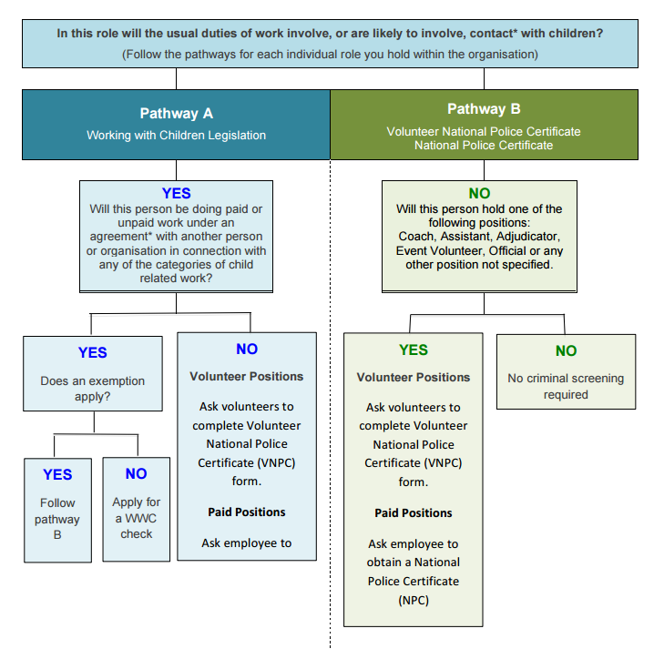

**\*Contact**– Contact is defined as any form of physical contact, oral communication, whether face to face, by telephone or otherwise electronic communication. It does not include contact in the normal course of duties between an employer and an employee or between employees of the same employer.

**\*Agreement** – An agreement (written or unwritten) by a person with another person or organisation, to engage in child-related work either for payment or on a voluntary basis.

**\*Categories** – There are 18 categories of “child-related” work in the WWC Act. A person is only in child-related work if their usual duties involve or are likely to involve contact with a child in connection with at least one of these categories and an exemption does not apply.

**\*Exemptions** – Full details of categories and exemptions can be found in the *GWA WWCC Association Guidelines*

# Recognising When a Child is at Risk of Abuse or Neglect

There are five main types of child abuse and neglect:

* Physical
* Sexual
* Emotional
* Psychological
* Neglect

A child can suffer one or more of these. Abuse and neglect can happen within a family or through a person outside the immediate family. Each kind of abuse has a range of signs, though just one sign on its own may not suggest abuse.

The information about signs of abuse may be helpful if you are concerned that a child or young person has been harmed or is at risk of being harmed.

**Physical Abuse**

Physical abuse is when someone is deliberately hurt, or is at serious risk of being physically hurt, by their parents or carers. This can include punching, kicking, shaking or throwing, scalding/burning, strangling or leaving a child alone in a car. It can also be from excessive physical discipline, or by being given drugs including alcohol these injuries are not treated as accidental.

Possible signs of physical abuse

* Broken bones or unexplained bruises, burns or welts in various stages of healing
* The child or young person can’t explain an injury, or the explanation is inconsistent, vague or unlikely
* The parents saying they they’re worries that they might harm their child
* Family history of violence
* Delay between being injured and getting medical help
* The child or young person avoids physical contact (particularly with a parent or carer)
* Frequent visits to health services with repeated injuries, illnesses or other complaints
* The child or young person is frightened of a parent or carer, or seems afraid to go home
* Arms and legs are kept covered by clothing in hot weather

**Sexual Abuse**

Sexual abuse is children and young people being exposed to inappropriate sexual activity. This includes being involved in sexual acts (masturbation, fondling, oral sex or penetrative sex); or witnessing sexual activity, either directly or through pornography

Possible signs of sexual abuse

* Inappropriate sexual behaviour for their age and developmental level
* Inappropriate knowledge about sex for their age
* Disclosure of abuse either directly, or indirectly through drawings, play or writing
* Pain or bleeding in the genital area
* Fear of bleeding alone with a particular person
* Child or young person implies that they have to keep secrets
* Presence of sexually transmitted infection
* Sudden unexplained fears
* Bed wetting and soiling

**Emotional Abuse**

Emotional abuse is being treated in ways that damages a child’s ability to feel and express a range of emotions. This can be caused by behaviours that occur over time, such as verbal abuse and teasing, rejection, physical or social isolation, threats and bullying.

Possible signs of emotional abuse

* Parent or carer constantly criticises, insults and puts down, threatens, or rejects the child or young person
* Parent of carer shows little or no love, support or guidance
* Child or young person shows extremes in behaviour from aggressive to passive
* Physically, emotionally and/or intellectually behind others of the same age
* Compulsive lying and stealing
* Highly anxious
* Lack of trust
* Feeling worthless
* Eating hungrily or hardly at all
* Uncharacteristic seeking of attention or affection
* Reluctant to go home

**Psychological Abuse**

Psychological abuse is being treated in ways that damages a child’s self-esteem, personal and moral development and intelligence. This can be caused by behaviours that occur over time, for example, belittling, threatening, isolating and causing the child to feel worthless.

Possible signs of psychological abuse are similar to the ones for emotional abuse.

**Neglect**

Neglect is not providing enough care or supervision so that the child is injured or their development is damaged. It includes lack of food, shelter, affection, supervision, untreated medical problems and abandonment.

Possible signs of neglect

* Signs of malnutrition, begging, stealing or hoarding food
* Poor hygiene: matted hair, dirty skin, or body odour
* Untreated medical problems
* Child or young person says that no one is home to look after them
* Child or young person always seems tired
* Clothing not appropriate to the weather
* Frequent illness, minor infections or sores
* Hunger

**What you can do**

If you are worried about the wellbeing and/or safety of a child or young person, and have seen some of the above signs the flowchart below can offer guidance as to what the process is.

Talking to someone experienced in supporting families or in child protection can also help you decide what actions need to happen to keep the child or young person safe.

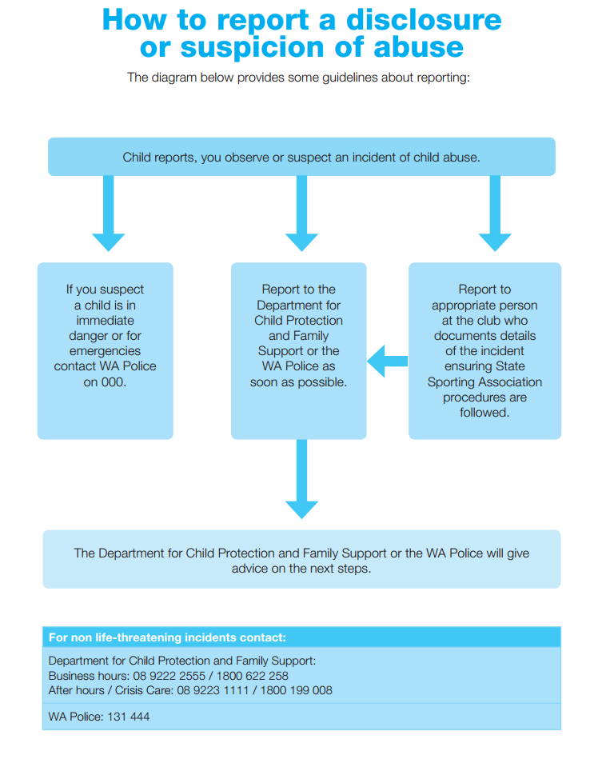

# 

# Attachment 1: Respond and React Process

**Receiving Interim Negative Notice and Negative Notice Process**

1. Individual goes through the process of applying for a WWC as per page 7
2. A copy of the Negative Notice is given to their employer or volunteer organisation.
3. The person is removed from child related work.
4. The individual submits their WWC card to the WWC Screening Unit (if they currently hold one while during the application process).
5. The club is to email the Executive Director of Gymnastics WA immediately.
6. The Executive Director will follow the record keeping process to ensure all information of the applicant is kept confidential and can be accessed on a as need basis, to ensure Negative Notice individual does not move to another gymnastics club/association or sport to engage in child related work.
7. The club or association is to follow its own record keeping process to store the details of the Negative Notice individual.

**Contacts**

Working With Children Screening Unit

You can contact the WWC Screening Unit during the hours of 8:30am – 4:30pm Monday to Friday.  
  
**Telephone**: (08) 6217 8100  
**WA Country callers**: 1800 883 979  
**Fax**: (08) 9221 6345  
**Email**: [checkquery@cpfs.wa.gov.au](mailto:checkquery@cpfs.wa.gov.au)  
**Postal address**: PO Box 1262 West Perth WA 6872  
**Assisted calls:**If you have a hearing or speech impairment and/or you use a TTY or a computer with a modem, please call ACE National Relay Service on 133 677 which will help you contact the WWC Screening Unit.

Gymnastics WA

Executive Director

**Telephone:** 08 9228 9399

**Fax:** 08 9228 9499

**Email:** [director@gymansticswa.asn.au](mailto:director@gymansticswa.asn.au)

**Postal Address:** PO Box 1204, West Leederville WA 6901

# Attachment 2: Categories of Child Related Work

Under Section 6 of the Working with Children (Criminal Record Checking) Act 2004 people are in child related work and require a Working with Children (WWC) Check only if the usual duties of the work involve, or are likely to involve, contact with a child in connection with one of the following categories:

|  |  |
| --- | --- |
| Category | Definition |
| 1. Child care service | As defined in the Child Care Services Act 2007 s4 or an education and care service as defined in the Education and Care Services National Law (Western Australia) s5(1) |
| 1. Community Kindergarten | Registered under Part 5 of the School Education Act 1999 |
| 1. Educational institution for children | Defined in the School Education Act 1999 but does not include universities recognised or established under a written law or educational institutions prescribed by the WWC regulations. |
| 1. Coaching or Private Tuition Service | A coaching or private tuition service of any kind, but not including an informal arrangement entered into for private or domestic purposes |
| 1. Arrangement for the accommodation or care of children | Whether in a residential facility or private residence, but not including an informal arrangement made by a parent of the child concerned or accommodation or care provided by a relative of the child |
| 1. Placement arrangement or secure care arrangement | Under the Children and Community Services Act 2004 |
| 1. Performance by an officer | As defined in the Children and Community Services Act 2004, of a function given to the officer under that Act. Officer means a person employed or engaged by the Department for Child Protection and Family Support, whether as a public service officer under the Public Sector Management Act 1994, under a contract for services, or otherwise |
| 1. Detention centre | As defined in the Young Offenders Act 1994 section 3; |
| 1. Community child health service |  |
| 1. Counselling or other support service |  |
| 1. Religious organisation |  |
| 1. Club, association or movement | Including of a cultural, recreational or sporting nature and whether incorporated or not, with a significant membership or involvement of children, but not including an informal arrangement entered into for private or domestic purposes |
| 1. Ward of a public or private hospital in which children are ordinarily patients |  |
| 1. Baby sitting or child minding service | Not including an informal arrangement entered into for private or domestic purposes |
| 1. Overnight camp | Regardless of the type of accommodation or how many children are involved |
| 1. Transport service specifically for children |  |
| 1. School crossing service | Being a service provided to assist children to cross roads on their way to or from school |
| 1. Children’s entertainment or party service |  |

# Attachment 3: Renewing WWC Card Online

**Overview**

There are now two ways to renew a WWC Card. For a card holder who’s WWC Card is due to expire within three months, and who is continuing child related work, they can now:

1. Lodge a paper application form at an authorised Australia Post Outlet or
2. Complete a WWC online renewal form

Online renewal is only available to eligible card holders.

[www.workingwithchildren.wa.gov.au](http://www.workingwithchildren.wa.gov.au)

1. Lodging a paper application
   1. Applicant completes a WWC Check application form
   2. Authorised organisation representative signs and confirms the applicant’s child related work on the application form
   3. Applicant lodges their application form at an authorised Australia Post outlet with the required identity documents, pays the fee and is issued a receipt
   4. Applicant and the representative can track the application status using the receipt number on the WWC Check website
   5. Applicant is notified directly if application has been approved or returned with an Interim Negative Notice or Negative Notice
2. Completing a WWC online renewal
   1. Applicant registers for WWC Check online services on the WWC website and is eligible to renew online
   2. Applicant completes the online renewal form, nominates the authorised organisation representative, pays the fee and prints the receipt
   3. Organisation representative receives the email, registers or logs into their account and confirms the applicants child related work
   4. Applicant and the representative can track the status using the receipt number on the WWC Check website

# Attachment 4: Parent Volunteer Exemptions

|  |  |
| --- | --- |
| **Category** | **Parent Volunteer Exemption** |
| 1. Child care service | Work carried out on a voluntary basis by a parent of a child to whom the service is being provided; or who is enrolled for, or otherwise ordinarily is provided with, the service. |
| 1. Community kindergarten | Work carried out on a voluntary basis by a parent of a child who is enrolled at the kindergarten |
| 1. An educational institution for children | Work carried out on a voluntary basis by a parent of a child who is enrolled at the educational institution. |
| 1. A coaching or private tuition service of any kind | Work carried out on a voluntary basis by a parent of a child to whom the service is being provided in connection with an activity in which the child is participating, or ordinarily participates.  When the coaching or private tuition is also in connection with a club, association or movement (including of a cultural, recreational or sporting nature and whether incorporated or not) with a significant membership or involvement of children, and the work is carried out on a voluntary basis by a parent of a child who is involved, or is ordinarily involved in some, or all, of the activities of the club, association or movement. |
| 1. An arrangement for the accommodation or care of children | Work carried out on a voluntary basis by a parent of a child in connection with an activity in which the child is participating, or ordinarily participates. |
| 1. Placement arrangement or secure care arrangement | No parent volunteer exemption |
| 1. Performance by an officer | No parent volunteer exemption |
| 1. Detention centre | No parent volunteer exemption |
| 1. Community child health service | Work carried out on a voluntary basis by a parent of a child to whom the service is being provided in connection with an activity in which the child is participating, or ordinarily participates |
| 1. Counselling or other support service | Work carried out on a voluntary basis by a parent of a child to whom the service is being provided in connection with an activity in which the child is participating, or ordinarily participates |
| 1. Religious organisation | Work carried out on a voluntary basis by a parent of a child in connection with an activity in which the child is participating, or ordinarily participates. |
| 1. Club, association or movement (including of a cultural, recreational or sporting nature and whether incorporated or not) with a significant membership or involvement of children | Work carried out on a voluntary basis by a parent of a child who is involved, or is ordinarily involved in some, or all, of the activities of the club, association or movement. |
| 1. Ward of a public or private hospital | Work carried out on a voluntary basis by a parent of a child in connection with an activity in which the child is participating, or ordinarily participates |
| 1. Baby sitting or child minding service | Work carried out on a voluntary basis by a parent of a child, to whom the service is being provided, in connection with an activity in which the child is participating, or ordinarily participates. |
| 1. Overnight camp | No parent volunteer exemption |
| 1. Transport service specifically for children | Work carried out on a voluntary basis by a parent of a child who is a passenger on the transport service, or is ordinarily a passenger on the transport service. |
| 1. School crossing service | Work carried out on a voluntary basis by a parent of a child who is enrolled at the school. |
| 1. Children’s entertainment or party service | Work carried out on a voluntary basis by a parent of a child in connection with an activity in which the child is participating or ordinarily participates. |

# Attachment 5: Record Keeping

Keeping records is essential to demonstrate that you are complying with the Working With Children (WWC) Act and other legislations. This process is applicable for those who are undergoing the WWC application process, the Volunteer National Police Clearance or the National Police Clearance

Record keeping should include:

* List of all employees, volunteers and students  engaged in child-related work with your organisation

* WWC Check application numbers, VNPC and NPC certificate numbers and expiry dates
* Copies of WWC Cards, VNPC and NPC certificates
* All notifications received from the WWC Screening Unit and or CV Check
* Copies of any WWC Card validations from the WWC Check website; and
* Any Interim Negative Notice(s) or Negative Notice(s) issued and the action taken by your organisation.

This information should be:

1. Stored securely

* GWA criminal record keeping spreadsheet is electronically saved in the server.
* Only GWA staff have access to the server, however only the Executive Director and Club Development Coordinator will have access to this document.
* GWA Staff can ask for information on specific individuals, but only the allocated staff can retrieve that information
* The details of the individual will be delivered to any Staff member requesting it by paper, so that the paper can be terminated.

1. Remain confidential
   * GA have limited staff who can access the GWA criminal record spreadsheet.
   * Every time information from the spreadsheet is sourced and used for the purpose of GWA activities, the staff members involved in using and sourcing the information must sign and date a confidential log book, to indicate their understanding of confidentiality.
2. Updated regularly.
   * On a weekly basis the GWA criminal record keeping spreadsheet will be updated from the information that is sent by clubs, individuals and staff.
   * As the spreadsheet will include information of when certificates and WWC cards expire, at least 1 month before the expiration date GWA will notify the individual and club to renew their criminal records checks, and encourage to follow the process to renew outlined in their clubs Member Screening Procedure.

A template for clubs and associations to use to record WWC, VNPC and NPC information can be found [**here.**](GWA%20Criminal%20Record%20Spreadsheet.xlsx)

# Attachment 6: Uploading WWC Card Details on Gymnastics Online Portal

It is a requirement by Gymnastics Australia that all club personnel that require a Working with Children Check are uploaded on the Gymnastics Online Portal.

Only organisation administrators have access to the Gymnastic Online Portal. Club Personnel will receive notification via an email in the following scenarios:

* + - If their WWCC is missing
    - 3 months out from expiry of their WWCC
    - 1 month out from expiry of their WWCC
    - When their WWCC has expired

Club personnel are to contact their club when they receive notification as only organisation administrators have access to the Gymnastic Online Portal.

The steps for Club Organisation Administrators to update their club personnel WWCC information is as follows:

* + 1. Log into GOL, via [www.gymnastics.org.au](http://www.gymnastics.org.au) and click “Sign in”
    2. Click the hyperlink “Club Admin Home”
    3. Click the tab “Bad Data”
    4. Scroll down to the bottom of the page and click the hyperlink “Missing/Expired Working With Children Check Information”
    5. Click the name of the Club Personnel that needs updating
    6. Click the pencil icon in the top right hand side of the information box to edit information
    7. Ensure all fields are completed and then click the “Save” button
    8. A green banner on the top of the page will show and will say “Successfully Updated”