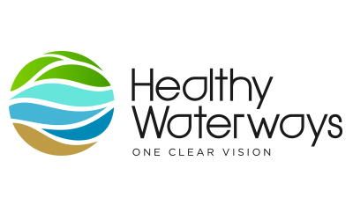
COMMUNITY MARINE DEBRIS GRANTS
REPORTING TOOLKIT
This toolkit was designed to help grant recipients fully understand their reporting requirements and provides information to make it easy to deliver great projects and create reports that display your overall grant objectives.

Reporting your achievements
Reporting Requirements
Summary reports demonstrate the effectiveness of projects funded through the Community Marine Debris Grant Program and assist us in evaluating our current grant programs.

If you have any queries after reviewing the template below or think you will have difficulty meeting the requirements please contact Sea World Research & Rescue Foundation researchandrescue@vrtp.com.au .

Reporting on the budget
The reporting process is about responsibly accounting for the funding your group has received. This identifies how the grant was spent in comparison to the intended expenditure. We highly recommend that your group accurately record the receipt and expenditure of each grant received. Any funds remaining at the completion of the Project are to be discussed to Sea World Research & Rescue Foundation.

Do we need to provide annual audited financial statements?
No, not as part of the reporting process.

When do you have to complete the Reporting process?
The summary report is due 7 October, 2016. Please notify Sea World Research & Rescue Foundation in writing before the due date if you need an extension of the reporting timeframe.

Tips on writing your Final Reports
Keeping track of the basic information and data after each clean up will contribute greatly towards the overall timeline of your project and make it easy for you to chart its progress. Also ensuring you complete a litter audit and collect data using the Tangaroa Blue data collection sheet will help you keep track of what your project has achieved.

Tips on documenting your project visually
The two main reasons for documenting projects visually are to be able to show the impact of the project over time and to use the photos for promotion of your project. With respect to showing the impact of the project over time it is important that you establish a ‘photo point’ and then take photos before and after a clean up.

Try to include colourful, eye catching and relevant photographs with your reporting and promotional materials; it may increase the likelihood of your project achieving media coverage.

Promoting your project
Undertaking your own promotional activities
Promoting your project in your local area can have huge advantages for your group. Getting the word out about events and activities will increase the profile of your group and encourage people in your local community to get involved. Please review ‘how to create a media release’ document for extra information.

Collect and include any support material that demonstrates the impact of the project and its results (e.g. media stories and photographs).

If you would like to submit an article for the Sea World Research & Rescue Foundation or Healthy Waterways e-newsletter, you can do so by following the guidelines below and sending your story to researchandrescue@vrtp.com.au. Each submission should include:

One article approximately 300 words in length saved as a Microsoft Word document and two to three high resolution images that illustrate the accompanying article. These images should be attached to the email and not embedded in the document.

Please include captions for each attached image that explain who is in the photos and/or what they illustrate. Also, please ensure that we have permission from any people featured in the photos to use the photo.

Please note that due to space restrictions we cannot guarantee that all submissions will be included.

Social Media
We encourage groups to share their stories, news, photos or videos through the Sea World and Healthy Waterways Facebook pages.

Summary Report Template
- Organisational information
Group name: | Underwater Research Group Queensland Inc. (URGQ)
Project title: | Marine Debris and Threatened Species Curtin Artificial Reef
Website: (if applicable) | https://www.revolutionise.com.au/urgq/curtin-artifical-reef/curtin-artificial-reef-clean-up/
Location: | Curtin Artificial Reef, Moreton Bay Marine Park

- Please provide a summary of your project (300 word limit)
The URGQ received funding to undertake a three-year program of underwater clean-ups of Curtin Artificial Reef. URGQ owns its own Club house and a 6.8 ridged-hull inflatable vessel Diver 1. URGQ is a not-for-profit volunteer community group whose aim is to promote diving and research. The purpose of this project is to gather data to highlight the impacts of fishing gear on threatened marine species and share the information with school students and stakeholder groups such as fishers. The effort of underwater clean-up has been enhanced by the Sea World Rescue and Research Foundation Funding. A second vessel was secured to enable a great number of volunteer divers to participate in an underwater clean-up on the weekend of 7-10 October 2016. Members travel to Moreton Island and based themselves at Cowan Cowan. Underwater clean -ups occur each slack tide. The equipment used includes SCUBA, dive gloves, buckets with a hole in the lid to drop marine debris through and drainage holes in the sides. If necessary, a DSMB is used to bring the bucket to the surface. The marine debris is weighed and catalogued and uploaded onto the Marine Debris Database. During the weekend a total of 42 dives were made by 15 divers. The marine debris was collected from Barge 25, Estrella Del Mar, Utah , Tyres, Point Lookout, Concrete pipes, Kos I and Rock Driller Barge.

- Social outcomes-how were community/social needs met and awareness increased?
(Approx 100-200 words)
A motivational talk was developed and presented on 21 September 2016 titled “Marine Debris and Threatened Species – What YOU can do”. The presentation was a tended by members, guests and uni students. In total 30 people met at the club house. The talk was successful in that it reached the attendees and has resulted in attitudinal change regarding how they use and view plastics. The presentation will continue to be given to other groups to raise community awareness such as schools and dive groups. Images were uploaded to the Curtin Artificial Reef Facebook page.

- Environmental outcomes – please describe the environmental benefits of this project
(Approx 100-200 words)
The removal of fishing line, weights and lures reduces the possibility of species being caught or entangled. This is brilliantly captured on the video that was made where a diver releases a wobbegong shark caught on a fishing line and hook. The project has two significant parts: the filed component and the motivational presentation. Where each component reaches different audiences, those that can participate and have a direct impact on the marine debris issues and the broader community who may not be able to participate but which are engaged through the efforts of volunteers. Threatened species such as turtle are caught on and in fishing line. The removal of fishing line from the area reduces the potential for the loss of individuals from the population.

- Educational outcomes - what did the group itself gain from the project (e.g. new members, exposure)? (Approx 100-200 words)
The group is enjoying a renewed sense of purpose about the diving in which they engage. The project is enabling members to fulfil the objectives of the club as a research group. Members are keen to continue the clean-up dives into the future as a once a year project at their own expense. The project has increased awareness in the Club and the membership increased. Members are actively discussing the longer-term conservation of Curtin AR and the need to collect data to evidence the colonisation and range of species found on the reef.

The awareness of the amount of marine debris on Curtin Artificial Reef has been heightened due to the field work undertaken. The systematic collection of rubbish has promoted an awareness of the cumulative impacts of human activities and the need to monitor them. It has promoted an awareness of the variety of species which is leading to a new project which is to catalogue the species found at Curtin AR.

The educational talks have significantly increased the awareness of plastics and its effect in the environment. The presentation was a motivational talk aimed at inspiring the audience to make a change where that can. It has promoted members to post information about the reduction of use of single use plastics at events such as the Caloundra Music Festival and the use of straws and plastic cutlery. The presentation will continue to be given to stakeholder groups and on invitation.

- Please provide a quote (no more than one or two sentences) that captures the essence of what this project means to you and/or members of your group:
This project represents a unique opportunity for URGQ volunteers to work cohesively towards clearing marine debris from our local environment. It highlights the cumulative impact of recreational fishing on Curtin Artificial Reef and threatened species whilst promoting an awareness and interest of Moreton Bay Marine Park in the broader community.

- Project environmental outputs & impacts
 | Your statistics
Area of habitat cleaned | no. of meters
Number of clean ups conducted
Most common items found | Item | Approximate number per clean up
Table 1 – Summary of marine debris collected to date
Date | Curtin wrecks | No. Dives | Fishing Line & lures/hooks (kg) | Fishing  Weights (kg) | Anchors &  Line/Chain (m) | Other
TOTAL |  | 96 | 64 & 11 | 171 | 17 & 50
1 Aug 2015 | Southern | 6 | 8 | 11 | 3 & 10
22 Aug 2015 | Southern | 10 | 11 | 7 | 9 & 20
23 Aug 2015 | Mid | 10 | 9 | 5 | 5 & 20
5 - 7 Mar 2016 | Mid & Northern | 70 | 36 & 11 | 148 | 12 & 75 | 2 small Burley bins  2 large burley bins  1 line reel  1 spear  1 fishing rod  1 rod holder  1 toilet seat
7 – 10 Oct 2016 | Barge 25, Estrella Del Mar, Utah, tyres, Point Lookout, Concrete pipes, Kos I, Rock Driller and Statue | 42 | 4.4 &1 | 25.8 | 0 & 0 | 1 Bait bag  10m rope

- Project community outputs and impacts
 | Number of participants /volunteers | Number of volunteer hours contributed
Total no. for this project | 45 | 96 dives @ 1hr each = 96 hours in water time.  But whole weekends and personal finances have contributed to the project deliverables
No. new members/volunteers gained through project |  | 5
No. new partners gained through this project |  | 4

- PR & Marketing Outputs & Impacts
Media coverage and/or other promotional material: How did you promote your group, your project and the corporate sponsorship which you received within local and other media? Attach copies of any print media or promotional material obtained or produced. E.g. press clippings, photographs, advertisements, programs, written responses to your project.

Media organisation | Contact name and details of contact or publication | Date/s they covered  the project
Print | Facebook page and images – Liz Vang | 10 October 2016
Electronic
Community | Educational presentation – Liz Vang | 21 September 2016

- Awareness / Education Impacts
The publicity in our community around this project has increased … | Strongly disagree | Disagree | Neutral | Agree | Strongly agree
... awareness in conservation activity |  |  |  |  | X
… understanding in conservation activity |  |  |  |  | X
… action in conservation activity |  |  |  |  | X
... our group’s profile within the community |  |  |  | X

- Financial Report - Give an accurate account of how the project funds were spent.
Item  e.g. | Cost Description | Funding amount  (incl. GST) |  | In-kind contributions
 | Hire of boat | 1050
 | Petrol | 350
 | Travel, accommodation, food |  |  | 2550
 |  | 1400 |  | 2550

- Issues (if any) in delivery of project
The weather wasn’t very good and the visibility poor. I believe that it reduced the diver’s ability to easily identify fishing line to remove which resulted in less rubbish collected. Some damage was sustained to the vessel because of the winds changing overnight.

- Further Comments – Please include any further comments, group member quotes or thank you notes for our corporate partner.
This funding significantly contributed to overall clean-up effort. It enabled volunteers to participate in activities they would not otherwise have enjoyed. Importantly the project has had tangible and meaningful outcomes for participants and the broader community.

- Attachments (tick if supplied)
Please attach summary report documents as selected on the application form
Documentary
Photo journal
Blog
Media Release
Flyer
Other
Photographs - Please attach before and after images of the site or other relevant images of volunteers working on the project site. Please send high resolution (at least 1MB in size) electronic copies of these images.

Media articles - Please attach any media articles relevant to your project.
Maps- Please attach any maps that help to illustrate the location of the project site and extent of the works.
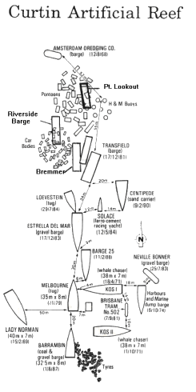
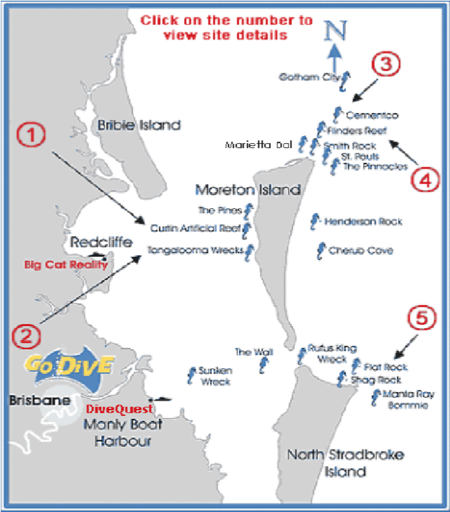
Number 1 shows the location of Curtin AR

Figure
2

–

Wrecks of
Cu
r
tin Artificial Reef

Figure
1

–

Location of C
urtin

within Moreton
Bay
Ma Marine Park
http://www.godive.com.au/brisban
e
-
div
e
-
sites.ht
m

Please complete your report ELECTRONICALLY and return via email to researchandrescue@vrtp.com.au
Or contact us by email if you require support to complete this document.

Thank you for your time and input

