Southern Highlands HOCKEY UMPIRE
2019 GUIDE

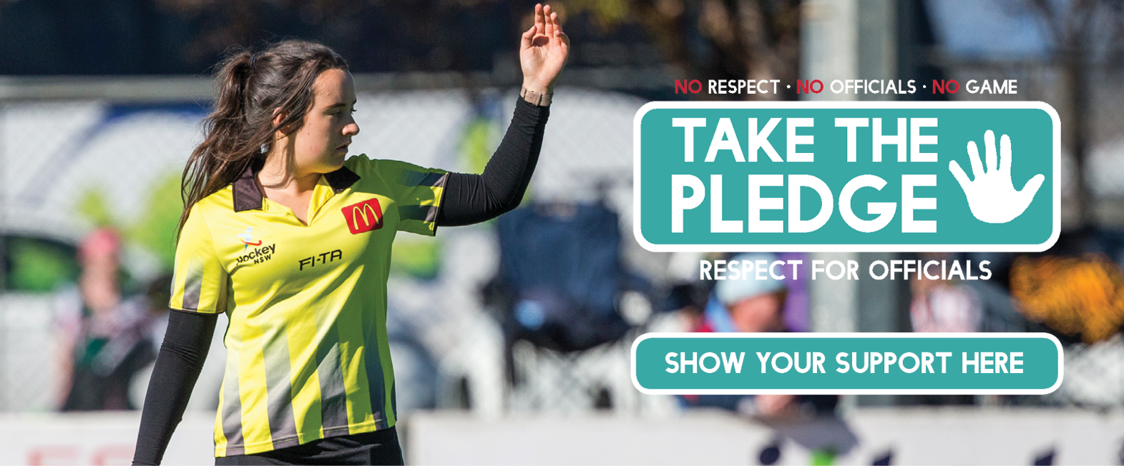

BEING A SOUTHERN HIGHLANDS HOCKEY UMPIRE

If you have received this document, then the chances are that you are interested in becoming an umpire but are unsure how to progress.

Don’t despair, all the necessary information and links are here to help you find the correct path and start your career as an umpire.

Umpiring the game of hockey is a fun and rewarding experience. To umpire well you need to work at the following skills.

- An umpire should be fit.
- An umpire should be able to manage people.
- An umpire should be fair and honest.
- An umpire must be able to communicate well.
- An umpire should come to understand the game both technically and tactically.
- An umpire should have a sound understanding of the rules and all the interpretations.

Whether you are a junior or senior, experienced or novice, Southern Highlands Hockey Association can help set you on the right path to start or develop your umpiring career. With the right help and a little bit of dedication you can take your umpiring from junior or community level right through to umpiring our own top grades and beyond.

Umpiring Committee

Southern Highlands Hockey Umpiring Committee is chaired by Brendon McDonald. This committee drives the umpiring and technical official programs supporting Southern Highlands Hockey – Education, Consistency, Training and Mentor Programs are our priorities. The Committee is working with state accredited umpires to create an environment which engages and recruits people to be involved in hockey umpiring and officiating.

Committee’s Mission Statement:

“To provide Southern Highlands Hockey players, coach’s, managers and officials, with the best possible game experience. That includes; professionalism, experience, respect, gratitude and teaching opportunities.”

Club Umpiring

Clubs can offer many levels of umpiring to its members from juniors through to seniors. This is a great place to start your career either as a junior umpire or an interested parent or player, and participate as a trainee/learner within our mentor program

Representative Pathways

Mentor Programs are available to assist your opportunity to become a regional, state or national standard umpire or official
Rules

FIH Rules

http://www.fih.ch/media/13164482/fih-rules-of-hockey-2019-final-website.pdf

Umpires Briefing Information – Senior
To be completed

Umpiring for Beginners
To be completed

Technical Officials Duties
To be completed

Umpiring the Game
To make the whole experience of umpiring enjoyable for all concerned there are several things an umpire can work on.
Providing a safe playing environment
Setting the tone for the game
Communicating well with co umpire, players and coaches.
Maintaining a reasonable level of fitness.
Keeping up with the current rules and interpretations of the rules.
applying the rules in the correct manner utilizing all the above to help.

UMPIRING HANDBOOK 2019

BACKGROUND
The handbook has been developed to provide all beginner umpires within the Southern Highlands Hockey Association with the basics required to assist with umpiring hockey within the Southern Highlands Hockey Association. Additional specific umpiring information will be made available as the season progresses through various workshops.

GUIDE FOR SOUTHERN HIGHLANDS HOCKEY UMPIRES
Advice will be given to you through the season at umpiring clinics regarding:
New rules;
Issuing cards;
Whistle tone;
Penalty corners and strokes;
Playing advantage: When to and what it is;
Feedback from your games;
Your conduct as a Southern Highlands Hockey umpire on and off the field.

This is also the time for you to mention any topics and ask any questions.

Following is a list of hints in relation to umpiring in addition to the rule book you have been provided with.

DRESS
You will be provided with an umpire vest or umpires shirt.

WHAT DO I NEED BEFORE I TAKE THE FIELD?
Whistle, pen or pencil, cards (green, yellow and red cards), rule book, reliable timekeeper.

GAME ALLOCATIONS
Umpires are allocated each week by the umpire committee and are displayed on the notice board at the fields and are on the internet at www.shhockey.com.au.
Throughout the season, panel umpires will watch your games and provide feedback on your performance.
There will be regular umpiring meetings during the season to update you on interpretations and provide feedback.

THE UMPIRE
There are two umpires in each game of hockey.
Together they are responsible for the entire field, including both team benches.
They are responsible for penalising breaches of the rules, maintaining game control, and to check that safety prevails and the game can be played in a skilful and enjoyable atmosphere.
Umpires require good co-operation and communication skills and to use common sense and good judgement.
Umpires need to stay calm and concentrate always and not be afraid to penalise unsporting and dangerous play.
Whistle: An umpire needs to blow the whistle firmly and clearly and to use tone variation.
Signals: An umpire needs to signal clearly and positively using the approved signals.

Initially you might feel more confident in the company of one of the senior umpires. Having a friend will distract you and may impact on your ability to make good decisions. ONLY APPROVED ADULTS ARE TO HELP YOU UMPIRE

SCORING A GOAL
A goal is scored when a ball has completely crossed the goal line on the ground or in the air. It must have been touched by an attacker’s stick inside the circle. When a goal is scored, the umpire shall blow the whistle and turn and point both arms to the centre of the field.
Note: The ball does not have to hit the backboard to be a goal. The exception is, the first shot at goal off a short corner the ball does have to cross the line at the height of the backboard if only touched by the attacking team.

INFRINGEMENTS: WHAT A PLAYER CANNOT DO
Stick: A player cannot play the ball with the back of the stick.

Feet: A player cannot stop or play at the ball with their body, leg, foot or arm.

Obstruction: A player cannot step into the way of another player who is trying to play at the ball.

Rough Play: A player cannot push, trip, or interfere with an opponent in any way.

Tackling: A player cannot hit, hook or hold an opponent’s stick with their stick.

Abuse: A player cannot abuse another player, umpire, official, spectator or team official.
PENALTIES

These are awarded following intentional or unintentional breaches of the rules. The umpire is responsible for recognising the breach and then applying the appropriate penalty.

If the breach was UNINTENTIONAL AND OUTSIDE THE CIRCLE, the whistle is blown and a free hit is signalled.

If the breach was INTENTIONAL AND OUTSIDE THE 25 YARD (22.9 METRE) AREA,
The whistle is blown louder, to convey to the players that the breach is not acceptable. Then the free hit is signalled (in some circumstances a card should be issued).

If the breach was UNINTENTIONAL AND INSIDE THE CIRCLE, the whistle is blown and a free hit is signalled as either a penalty corner for the attackers or a free hit for the defender.

If the breach was INTENTIONAL AND INSIDE THE 25 YARD (22.9 METRE) AREA,
the whistle is blown louder to convey to the players that the breach is not acceptable. The free hit is signalled. For defenders, this would be a clearance. For attackers, this would be a penalty corner or a penalty stroke (note that a penalty stroke is given for an offence by a defender in the circle which prevents the probable scoring of a goal). Intentional breach’s MUST attract a penalty card to the player.

Note: Please consult the rule book for further information.

CARDS (GREEN, YELLOW AND RED)

For any offence, the offending player may be:

Cautioned (indicated by spoken words);
Suspended for a minimum of two (2) minutes of playing time (indicated by a green card)
Suspended for a minimum of five (5) minutes of playing time (indicated by a yellow card).
For the duration of each temporary suspension of a player on or off the field, the offending team plays with one less player.
Permanently suspended from the current match (indicated by a red card).
For each permanent suspension, the offending team plays for the remainder of the match with one less player.
A personal penalty may be awarded in addition to the appropriate penalty.
Suspended players must remain in a designated place until permitted by the umpire who suspended them to resume play.
Suspended players are permitted to re-join their team at half-time after which they must return to a designated place to complete their suspension.
The intended duration of a temporary suspension may be extended for misconduct by a player while suspended.
Permanently suspended players must leave the field and its surrounding area.

IMPORTANT THINGS TO REMEMBER WHEN AWARDING A PENALTY STROKE

The stroke taker may only push or flick the ball.
The defending goalkeeper must stand with both feet on the goal line and must not leave the goal line or move either foot until the ball has been played.
When the player taking the stroke and the defending goalkeeper are in position, the umpire blows the whistle to indicate that the stroke may be taken.
The player taking the stroke must not fake at playing at the ball.
If the shot is saved or misses the net, play is restarted with a16 yard (14.6 metres) hit.
Umpires are to ensure that spectators are not walking past or standing behind or beside the goal while the stroke is being taken.

SPECIAL RULES FOR GOALKEEPERS

Goalkeepers can do each of the following but only in their circle areas.
Use any parts of their body to play at the ball.
Deflect the ball over the backline.
Stop or deflect the ball with the stick above shoulder height, if it isn’t dangerous to
other players.
If the goalkeeper plays the ball outside the circle it must be with the stick only.
‘Kicking Back’ Goalkeepers are NO LONGER PERMITTED. If a team does not have, or chose to not use a goalkeeper, no player has goalkeeping privileges, and all players are to be considered field players.

AFTER THE MATCH

Meet with your co-umpire and team managers
Check that all details are recorded correctly on the two team cards; scores and scorers and green, yellow or red cards awarded.
Write and sign your name at the bottom so that it can be read.
Don’t get caught in heated discussion with coaches, players or spectators. If anybody wishes to discuss your performance, refer them to the umpire committee.
If you feel uncomfortable with comments from players, coaches or spectators, there are SHHI procedures in place.
If it is the player causing the problem, use your cards to control the game.
If it is the team official or spectator causing the problem, send the captain off the field. Sometimes just the warning that this will happen is enough to ease the situation.
If none of the above have worked stop the game, and inform the person involved
That the game won’t continue till they have left the complex. Once the matter has been addressed, re start the game and report the incident on the team card
After the game concludes, report any incident on the team card, photograph your report and advise the Umpire Committee.

ACCREDITATION
Contact Brendon McDonald if you want to become accredited or have your current Southern Highlands Level reassessed.

