Dragon Boating Western Australia (DBWA) 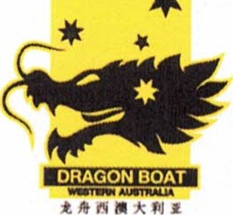
Safety and Health Policy
DBWA is committed to the safety, health, and performance for the Western Australia (WA) dragon boat sport and providing WA clubs, athletes, volunteers and visitors with a positive and supportive sporting environment.
All registered members, including volunteers shall take reasonable care for their own safety and health, report unsafe acts and conditions, and behave in a manner that reflects safe practices and standards.
DBWA will endeavour to:
- provide, in so far is reasonably practicable, a safe sporting environment for all members, athletes, volunteers, visitors, stakeholders and the community
- comply with applicable legislative obligations, including safety and operational procedures of the governing sporting body Australian Dragon Boat Federal (AusDBF)
- monitor sporting activities and improve safety performance, through ongoing consultation and communication and periodic review of safety systems manage identified hazards and where possible implement control measures to eliminate or to reduce to as low as reasonably practicable risks to safety and health that are within DBWA's control and authority investigate reported incidents where appropriate, implement and communicate corrective actions actively promote safety and health practices and standards with WA clubs, members, athletes, volunteers, and stakeholders identify and arrange appropriate training for individuals with safety and health responsibilities.
- promote and support an inclusive culture within the WA dragon boat sporting community
Barbara Clarkson President

Committee Representative Position
Signature Date

