Gawler Rangers history from the beginning
In 2007 my grandchildren were getting to an age that I wanted them to start playing teeball and thought there must be many young people in our area who won’t have the opportunity to play this great sport of baseball unless I do something about it.
In the 1980s I had formed a winter baseball team called the Gawler Bunyips, sponsored by the Bunyip newspaper. but it was never intended to be a summer team.
I rang the South Australian Baseball League, at that time run by former umpire Paul Begg, who was very enthusiastic about the idea of a new club. I rang good friend Robert Laidlaw and local businessman Len Goulding and we negotiated with softball, led by Heather Jackson, to play at Karbeethan Reserve under the softball banner. We were allowed to play on the ground on alternate weekends, softball using it the other weekend.
Paul Begg and the grounds committee came out to inspect the ground and gave approval.
AT THE START August 8th was the first announcement of the new club. A story and advertisements appeared in the Bunyip and area paper NewsReview.
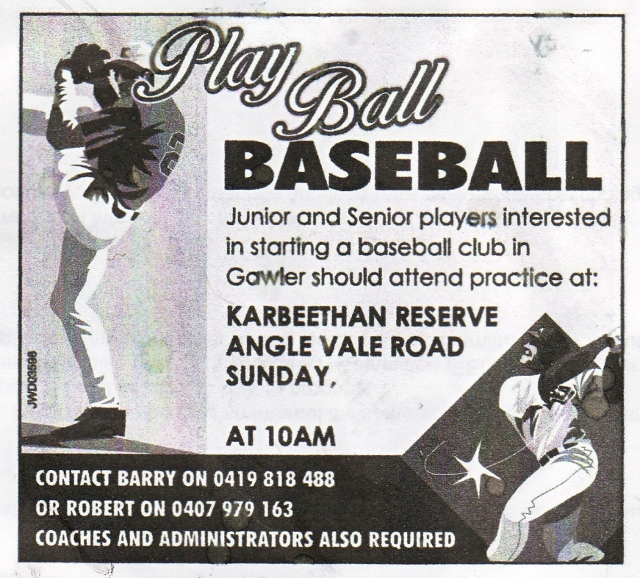
COACH The next thing was to find a suitable coach. Because of my association with Mike McClarty over many years I knew he would be the perfect person to be club coach. Mike was always full of enthusiasm and players liked and respected him. It was a good choice.
FIRST PRACTICE After the advertisement and story appeared in the Bunyip, we had no idea what to expect on the first morning. We asked baseball coaching legend Ron Harvey to help. We had a really good turnup and Ron set up various coaching stations. However, he had only just started when he was called away on an urgent family matter. The enthusiasm by all participants was evident.
We were very pleased to see the Clark family, father Ken and sons Shaun, Ricky and Matt. As it turned out, it would have been difficult to continue without them. The club owes a great debt of gratitude to Ken Clark for arranging our containers. We weren’t allowed to play down the clubhouse end and we met strong resistance from hockey thinking we would ruin their playing surface. We also weren’t allowed to have a mound on a permanent basis and were given, on loan, a fibreglass mound by SABL. Ken, Shaun, Ricky and Matt Clark built the mound and took it down every time we played. Not only the mound, but the backstop and also did the line marking.
A steering committee was formed. We had no money so my wife Pat and I put $10,000 in for working capital. Apart from that, the club had very little funds. I was president, Robert was secretary for the beginning of the season but, due to pressure of work had to stand down, so I took over the role. Pat agreed to be treasurer, Clark family volunteered for the committee, Kevin Soar was grants officer and set about obtaining money from any source he could find, Mary O’Connor looked after Teeball and Chris Penfold was available for any job allotted to him. We won a contract to deliver phone books in the area, and all committee members and most of the players pitched in to deliver.
CLUB NAME The club needed a name. Several suggestions including Locomotives (many trains were built in the Gawler workshops), Twins (because of two rivers that join in Gawler), but RANGERS was decided because of feeling of space and our semi rural location.
CONSTITUTION We needed a constitution in a hurry, so we asked several clubs for their documents and Robert and I came up with something that could be improved on in the future, but sufficient to have us registered as an incorporated club.
COLOURS Next we needed colours. We wanted red, white and blue. However, these colours were rejected by SABL who wanted Purple and Black or Black, blue and grey because the old Central District baseball team wore red, white and blue. We persuaded them that Texas Rangers, Glasgow Rangers, New York Rangers are all red white and blue and so our colours were accepted. Mary gave us some designs for the lettering.
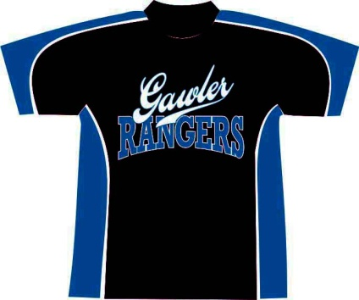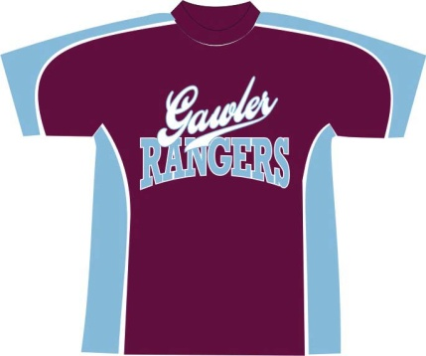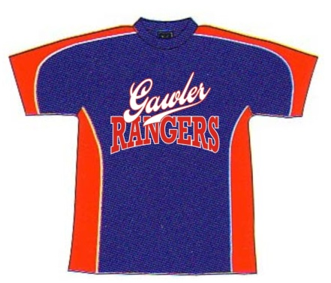
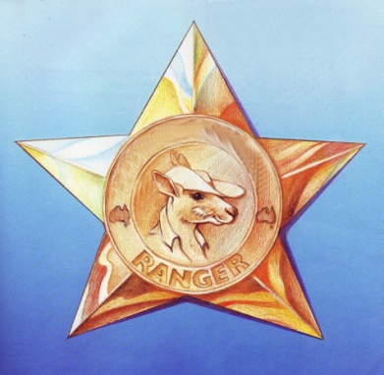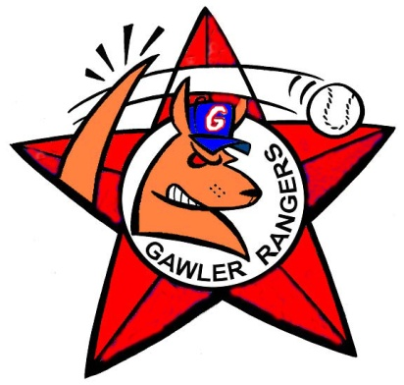
LOGO Pat saw this kangaroo in a children’s book, I asked for a kangaroo swinging a bat. Robert had a friend who came up with the tail hitting the ball.
UNIFORMS Time was marching on and we needed a uniform and cap for our first game. We went to local company Im-Press Promotions and tops and caps were picked up the day before the first game.
FIRST SEASON. We had two senior, Division 4 and 7 and two Little League teams. Our first ever A grade win against Goodwood on Nov 24th 2007 when the Clark brothers were heroes to score the winning run in a 10-9 thriller
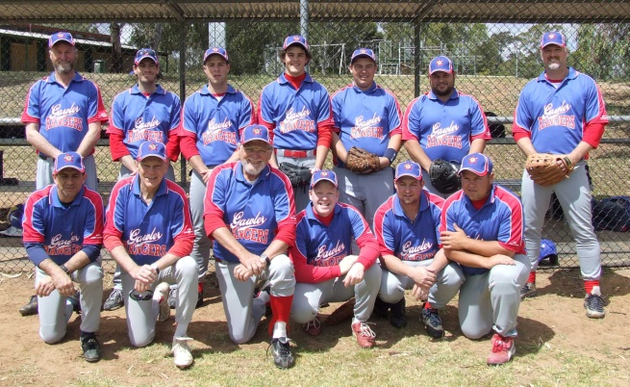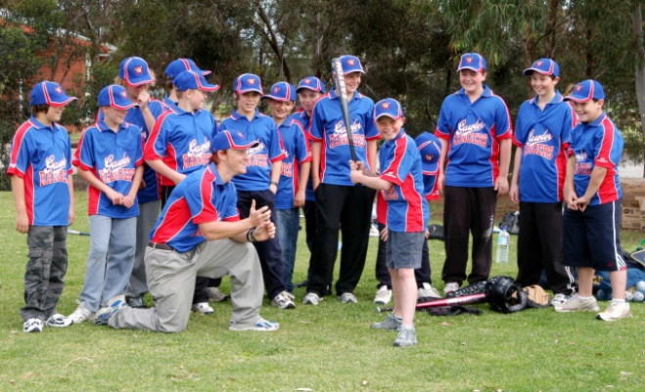
The first A grade team that played Northern Districts and coach Mark Amphlett with the juniors.
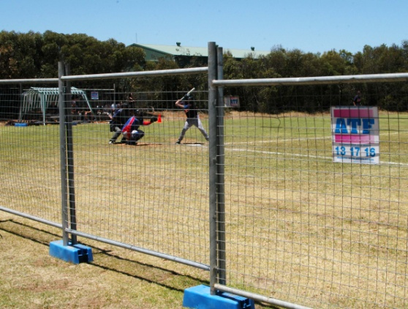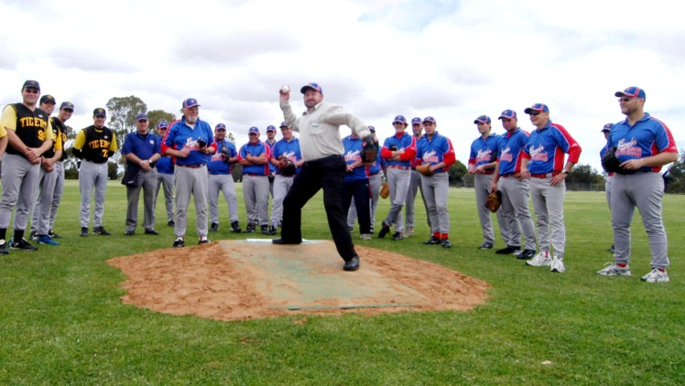
Mary O’Connor arranged for ATF to sponsor us by way of donating some temporary fencing for spectator protection. Gawler mayor Brian Sambell threw the first pitch at our first home game.
TEEBALL Mary assembled a wonderful team of helpers and first season we had four teams. Before long we had up to 80 juniors playing in a variety of teams.
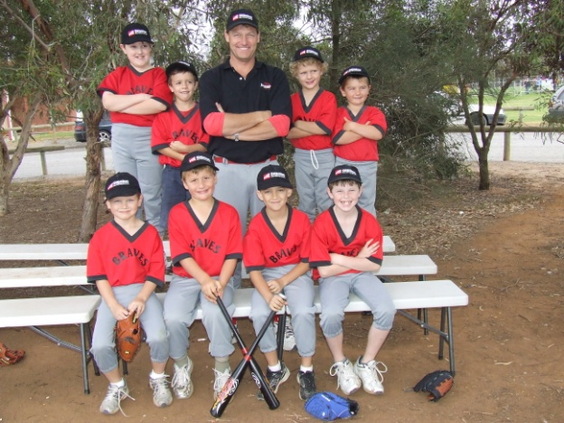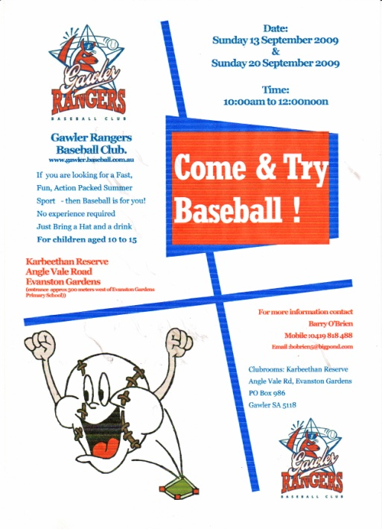
One of the first Teeball teams with David O’Brien coach and present day Gawler players Link and Wyatt Ryan and Thomas Norley, now with Golden Grove Central Districts.
GROUNDS. Right from the start our aim was to get into Div 1 within 5 years. We knew that to do this we would need a better playing field with two diamonds. Gawler council promised our own grounds when the proposed Karbeethan extension went ahead in 5 years time. This, of course, didn’t happen.
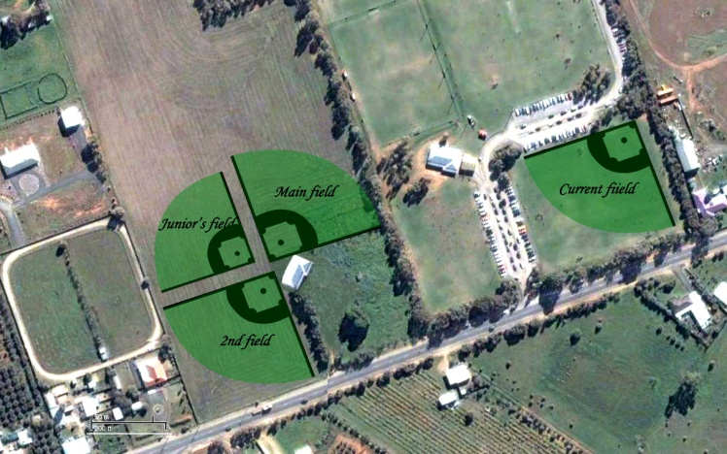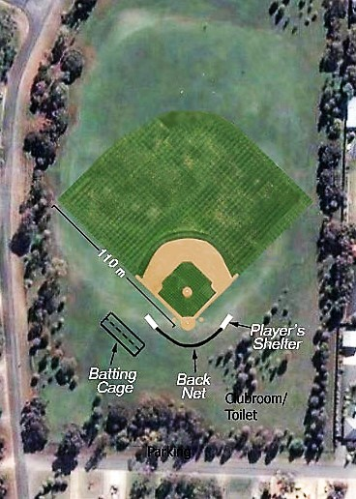
The original proposal for Karbeethan expansion and the council’s plan of Hemaford Grove field.
SECOND SEASON Three senior teams and two junior, one an Under 14 that brought in our first premiership, an outstanding achievement. The team was coached by former Port Adelaide stalwart Ralph Pearce, who was now living in the area, and made up mostly by the Little League players from the previous year. Not only did we win the big one, but Brad Torkington won the medal and Nathan Humphrys was runner up. Robert Laidlaw coached the Little League. 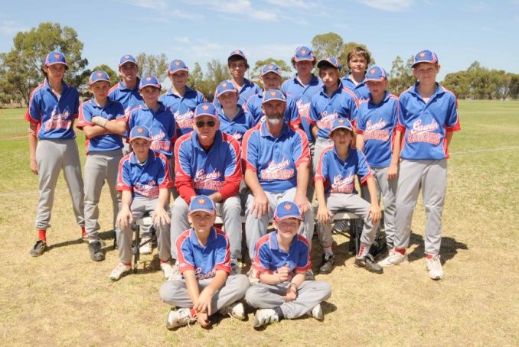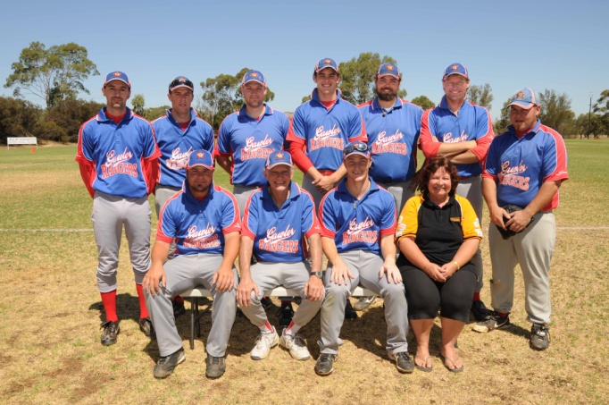
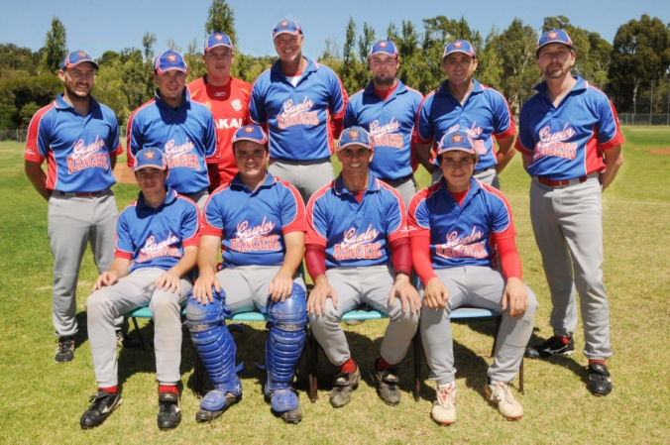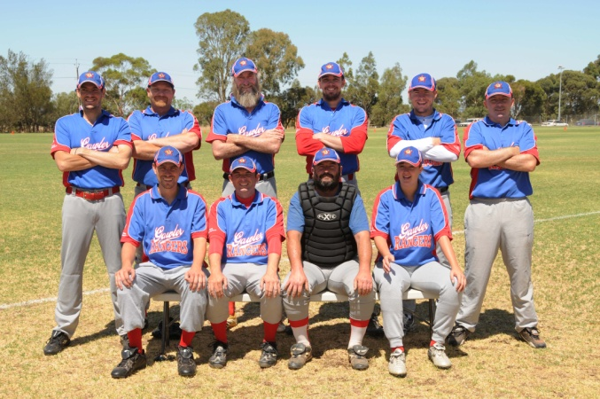
THIRD SEASON Our original uniform top that was hastily created made way for a new, beautiful red, white and royal blue that was the envy of many clubs. The cap was changed also although the design the players wanted wasn’t readily available and the club had to purchase a large order from China through Greatrex to get the red peak and correct royal blue.
The club brought a Canadian player, Mark Terrana, out and he was a terrific asset to the club. He and I visited all the schools in the area and gave clinics. I made note of anyone who stood out and they were contacted individually by letter through the school. This built up our junior squads.
We were in negotiation with Gawler Trotting club to have two diamonds in the centre of the trotting track. After several meetings, also a meeting with Gawler and Barossa Jockey Club regarding a diamond on the centre of the racetrack, but this was discarded. The trotting track option was perfect. The club had a bore and water allowance not being used and we were in a drought with water restrictions in place. This fell apart when Highways announced they were going to put North East Freeway right through the centre of the track.
The council was sick of me at council suggesting every bit of vacant land in the district for a ground. One day I received a call saying we could have a ground at Hemaford Drive, Gawler East. It was perfect. There was a raised area behind home plate for spectators, shady trees and quite a distance from neighbours. It was a bit out of the way, but fitted in with the plan to expand into the Barossa Valley. We had a training session there with our club members, both junior and senior. I was away on holiday and Mary had to face a barrage of complaints from, seemingly, everyone in the district.
They insisted there would be wild alcoholic hoon behaviour, drugs, noise etc. At the council meeting many turned up in force to ensure council not allow us to play on their precious turf, which is still underused.
The Gawler East Delfin expansion was the next target and things seemed very promising as we were asked to produce a business plan explaining the club and its expansion possibilities. However, once again this came to nothing.
After the ill fated council meeting I had discussions with Willaston Football Club president Ray Cockshell that led us to make Willaston Oval our home ground as we were still under the constraints of sharing Karbeethan with softball. Willaston was perfect with batting tunnels, canteen overlooking the ground, huge playing field, parking on site etc.
However, I became very ill not long after the season started and had to give up all my duties. Robert took over as president. Graham Mayfield was a tower of strength helping Pat organise the canteen. That season we had four senior and four junior teams as well as about 80 teeballers run by Mary. Unfortunately the football club couldn’t work in with training times with baseball and after two years it was necessary to come back to Karbeethan. However, this time we were given sole use of the diamond.
Now, as I write, the excitement of our new diamond and facilities, with lighting of an intensity to allow night games and our possible promotion to Division one has me greatly optimistic and looking forward to our very bright future.
Barry O’Brien
Gawler Rangers Club Founder

