ESPERANCE HOCKEY ASSOCIATION
Management Meeting Minutes

Time: | 6.07pm
Date: | 8th February 2024
Location: | Club House
Chair: | Angela Hill
Attendees: | Ange Hill, Matt Ryan, Niccole Cooper, Fraser O’Brien, Tom Edwards, Tash McCarthy, Rachel Norwood, Nia Stevens, Terri Herbert, Sam Stubna
Apologies: | Sara Harcourt-Smith, Tash Woodhouse, Jan Clawson, Rhys Bratten, Ian O’Dea
Minute taker: | Terri Herbert

 | Item | Recommendations | Summary of discussion |  |  |  | Actions
6.35pm | Minutes from previous meeting | Any business arising? | - NIL
 | Minutes of the previous meeting were read by all in attendance. They were accepted as a true and accurate record. |  |  | Moved: Matt Ryan |  |  | Seconded: Niccole Cooper
 |  |  |  | All in Favor: Passed unanimously
 | President’s Report  (Angela Hill) |  | - Attachment 1
 | Correspondence  (Terri Herbert) |  | As below
 | Treasurers Report  (Sara Harcourt-Smith) | BAS lodgement to be sourced out.  Goal post past sponsors to be asked if they wish to continue to sponsor for another period. If not signs to be taken down and replaced.  Matt Ryan to get a credit card | - Hardly any transactions have gone through so full financial reports we not run this meeting.  - The transfer from MYOB to QuickBooks has been all smooth sailing and easy  - The move from Westpac Bank to ANZ Bank has been completed, with Westpac Bank accounts being closed down. We now have 5 different accounts within ANZ:  - Working account for the Turf Project – Balance $0.00  - Savings account for Turf Project – Balance $139,437.00  - Working account for Hockey Association – Balance $40,904.16  - Savings account for Hockey Association – Balance $100,195.01  - Petty Cash (Linked to Debt Cards) – Balance $91.70  - Turf Project Invoicing:  - All invoices for the Turf project were sent out before Christmas  - $20,000 still outstanding in invoices  - Many of these were businesses who have been waiting for the GST registration to be completed  - GST Registration:  - GST registration for the association has been completed thanks to Ange!  - This will mean Quarterly BAS reports needing to be lodged to the ATO  - While this is a reasonably simple process, I would like to propose using an outsourced local Bookkeeper for lodging the Quarterly BAS’s.  - Tab Meerman from Esperance BAS & Books has said she would happily take on the Association. For a quick review and lodgement every quarter for $50.00.  - I believe that this would be a good practice to put in to place from the beginning  - The first BAS lodgement will be due by the end of this month (For the December transactions). I am happy to lodge this one as it will be small, but would prefer if discussions could begin with Tab to use her in the future.  - Goal Post Sponsorship  - We have received $400 from South East Fire & Safety for another 2 years of goal post sponsorship. They approached us.  - Did we want to approach some of the smaller businesses in town that weren’t keen on turf sponsorship to fill the remainder of these spots?  - Credit Card Holders  - Since we have changed to ANZ currently Ange & I are the only two card holders  - I have spoken to Fiona Ryan and since I have gotten a Woolworths account card for the kitchen, she does not believe she will need a bank card (Have accounts at almost all other shops that the kitchen uses).  - Ange raised a motion for above Moved Ange, Second Matt  - Goal Post Sponsorship Fire Crew have paid 2 yr sponsorship. Approach everyone else that has one currently to see if they want to continue for $400 for 2yrs.  - Nicc Cooper moved for Matt Ryan to have credit card. All in favour |  |  |  | Sara to complete this quarterly BAS then source out for future BAS lodgements.  Tash & Rach make a list of current goal post signs and let Terri know. Whom will email each business asking if they want to proceed with sponsorship? Sara to send invoices out to businesses that agree.  Sara & Matt to make arrangements for Matt to have a credit card.
 | Treasurers’ reports were presented to all in attendance. They were accepted as a true and accurate record. |  |  | Moved: Ange Hill |  |  | Seconded: Nia Stevens
 | Motion 1: For BAS lodgement to be completed by a third party to show good code of conduct and safe harbour of provisions, sourced through Sara. |  |  | Moved: Ange Hill |  |  | Seconded: Matt Ryan
 |  |  |  | All in Favor: Passed unanimously
 | Motion 2: Matt Ryan be the third credit card holder. |  |  | Moved: Niccole Cooper |  |  | Seconded: Rachel Norwood
 |  |  |  | All in Favor: Passed unanimously
 | Women’s Report  (Sam Stubna) |  | - Team delegates were contacted regarding player numbers, training schedules and requesting a copy of their uniforms.  - ATM Furies - 15/16, Bacchus - 15 need goalie, Emu - 13, Legs - 7 lots juniors, Sharks - 10, Mallee - 11 need goalie, Condy - 11  - Sam will work with Sharks & Legs to fill teams with new members  - Biggest challenge in women’s comp is filling goalie positions.  - Need to think about goalie specialist clinics to help this void? |  |  |  | Sam to start working on draft fixtures
 | Men’s Report  (T Edwards & R Bratten) |  | - Tom will check with teams as to how they are tracking. |  |  |  | Tom to start working on draft fixtures
 | Umpire Report |  | - Tash been looking for resources from hockey WA and Hockey Australia websites and downloading.  - Whistle Wednesday or similar will be back  - Discussed holding mini umpire discussions at end of day reports but thought this might not be the most appropriate opportunity.  - Hockey WA Umpire session to be help during season, Tash will liaise with Angela
 | Registrar Report  (Nia Stevens) |  | - Condingup GoldStix is up and running, registration period has been extended for any late regos.
 | Turf Report  (Ange Hill) |  | - The first round of Sponsorship Invoices went out in December, and most have been paid. We currently have $139,437 in the Redevelopment account.  - We had quite an ordeal in registering for GST, but we finally succeeded!  - As mentioned in my President report we had x2 Turf fundraisers since our last meeting. Thanks to all who contributed.  - I did apply for the Mt Burdett Foundation for a grant but unfortunately, we were unsuccessful. I have not heard back from the Esperance Bay Rotary Club.  - We are due to hear from the State Gov at the end of this month re: CSRFF grant.  - Our next meeting is to be scheduled.
 | Junior Report  (Niccole Cooper) |  | - Meeting held on Tuesday with some new committee members.  - Ran through roles and responsibilities at last junior committee meeting.  - Junior Coordinators role is to provide support to each of you in your roles and oversee the junior competition. I attend the EHA Management Committee meetings and provide a conduit for information between both committees. I put together the fixtures and help grade coordinators to allocate Coaches and Team managers to each team.  - Hook in2 Hockey Coordinator – Jayme Bergman Jayme runs our Hook in2 Hockey program for PP-Yr1 students. It is a fun program designed to promote a love of the game, whilst setting the kids up with the basic skills required.  - J2/3 Coordinator – Matt Ryan. Matt is in charge of the J2/3 competition. We find four coaches and Matt works with them to develop a skills program for the kids to participate in each week followed by a short, small format game.  - Grade coordinators  - J4/5 Coordinator – Sharna Lovejoy  - J6/7/8 Coordinator – Taryn Thomas  - U17 Coordinator – Michael Zani  - The grade coordinator role is to put together teams in the age group with assistance from myself and other members of the Junior Committee. Coaches need to be found and team managers allocated. GC will provide support to the Coaches and managers by being the point of contact for assistance. Each Saturday, the GC prepares the game cards for collection by Team Managers, then following the games runs the weekly presentation.  - Junior Umpire Coordinator – Niccole Cooper. Each week I will allocate the umpires for games and provide assistance where required. Once again, the U17 players will be rostered to umpire the J4/5 games so I will coordinate the mentors to assist this. J6/7/8 and U17 will be senior team duties. Any issues with umpiring should be directed to me.  - Carnival Coordinator – Tash Woodhouse. Tash takes on the mammoth task of coordinating our enrolment, transport, accommodation, coaches and teams for Junior Carnivals. She may request assistance from Grade Coordinators to spread the word and encourage early registrations for carnivals.  Coaches  - It’s time to start rallying the troops and finding coaches for 2024. If anyone has expressed interest to you please let me know. I will make contact with each of the coaches from last season and we will go from there.  - With regard to junior coaches – there were some concerns expressed last season around juniors umpiring junior players and not receiving any training from us. Suggestions for improvement this season?  - U17 Teams – Coaches choose managers.  - Coaching the coach. Adult supervision for junior coach.  - Trid Woodhouse – Coaches packs – NC to follow up.  - Teams made with no coaches, given deadlines.  Fixtures  - Proposed times for 2024 season  J2/3: 8-8.45  J4/5: 9-9.45 20min halves  J6/7/8: 9.55-10.50 25min halves  U17: 11.05-12.20 15min quarters  - Do we want to reach out to football and netball around conflicting times? What time for Hook in2 Hockey? School holiday rounds.  - Bye round last weekend Term 2. To be discussed once fixture dates are set. Possible junior round to coincide with Senior Lightning Carnival.  - Football Times  U12s 8am U14s 9am U16s 10am Colts 11am  Uniforms  - U17 uniforms require replacing. These can then be filtered down to the J6/7/8 comp to replenish numbers. Fundraising ideas? Suggestions for sponsors? Keeping in mind turf fundraising efforts.  - SOS Welding and Sportspower shirts priority  - Looking to replace all.  - Nic to see Greg to get price for 6 new playing strips.  General Business  - EDRA and RASP programme. Approach coaches for high school age kids for nominations 2-3 weeks into season.  - U17 to be started off central timer.  - Grade Coordinators to pull together coaches for a preseason meeting to inform expectations.  - Regos to open 12/2 to 12/3.  - Nic to discuss kitchen roster with Fi and see how they want to structure the roster.  - Representative shirts – for players to purchase their own. Nic to take to management meeting Thursday.
 | EDRA Report  (Tash Woodhouse) | Looking for hockey members to take part in the RASP program | - Last meeting was on 6 Dec 2023 which was the AGM. In taking over new roles, I was voted in as President. This will allow for more presence and visibility for the Esperance Hockey Association.  - Part of EDRA is the RASP or athlete talent development program. I have spoken about this before however I'd like to reiterate the great asset, we have access to as a Hockey Association.  - Our juniors from year 7 to 12 who are talented or strive to be a talent can learn about 3 of the 4 foundations of hockey.  - This includes nutrition, mindset and body knowledge and recovery. Juniors would have access to experienced professionals who have worked with or played in sporting teams at a high level.  - At the end of 2023 many of our RASP members left due to their age.  - Each sport has a representative and I am the contact for hockey (my second EDRA role).  - Geoff Poole is the Co-Ordinator, and is the person who all sporting contacts, such as myself liaise with.  - I'm looking for more hockey members to take part in this wonderful well-funded resource.  - Niccole Cooper and the junior committee have been asked to put forward names to me when junior teams are formed. If anyone has any questions please contact me.  - Another reminder about the funding that EDRA provide is for players who are representing their state/Australia and is provided for attending state/Australian trainings and games.  - We have increased the monetary funding amount for individuals and it is for players from 13 to 25 years.  - This funding has not been well used in the past and it is a great resource which EDRA want to provide.  - If there is any information or questions that I can take to the next EDRA meeting in March, please let me know. |  |  |  | Junior committee to provide names to Tash for nominations into the RASP program.
 | GENERAL BUSINESS
 | 2024 Meeting Dates & Type | Clear outline of what type of meeting is being held in fixture book for 2024  All meetings will be management meetings with the 4 required general meeting spaced out throughout the year.  Thursdays 6.30pm agreed time | - 2023 meetings and dates.  - Feb 7th – AGM & General Meeting – 2024 Management Committee  - 21st March – General Meeting  - 20th April – Exec Meeting  - 22nd April – Busy Bee  - 29th April - Season Started  - 6th May - Umpire Briefing  - 20th May - Hockey WA Umpire Session  - 25th May – Exec Meeting  - 6th June – General Meeting  - 12th July – Exec Meeting  - 15th August - General Meeting  - 7th September – Exec Meeting  - 17th September – Clean up Club Rooms  - 19th October – Committee Meeting  - 16th November – AGM & General Meeting |  |  |  | Ange & Terri to sort out meeting dates
 | Fixtures |  | - Busy Bee / Lightening Carnival 13th April  - Season start Day 20th April  - Women’s Country Week – 14th – 16th June  - Men’s Country Week – 21st – 23rd June  - Gala Awards Night – was discussed holding this the last round of fixtures, the semi or the prelim finals.  - 14th Sept Grand Final  - 15th Sept – Clean up Club Rooms |  |  |  | Tom & Sam to finalise start and GF date with their fixture scheduling.
 | Annual Registrations & Team Fees | Attachment 2 – 2021 – 2023 Fee’s  Registration Fees all to be rounded up  Team Fees to increase to $2000  Casual Players stay the same $10 | - Agreed that all fees be rounded up, small and gradual consistent increases to cover future turf costs.  - Team Fees – Increase $2000  - Casual Player Fees – keep same, best recruitment fee.  - All Service fees for payment through RevSport to be absorbed by the Association to cut out families having to pay more than once per family members.  - Fees going live and rego opening Monday for juniors and seniors  - Junior Registration will be open 12th Feb until 12th March |  |  |  | Nicc to send junior times through  Sam to do poster on canva for sending to schools and advertising about junior hockey  Plus, another one for call out for players all grades and abilities.  Casual guidelines put on board and in fixture books.
 | Credit Card Holders 2024 | Matt Ryan to get one. | - Fiona has expressed she will no longer need this as we have a Woolworth’s card set up now and other places the canteen get supplies have accounts.  - Discussion around do we need the third one, country week teams and carnival coordinators find it handy to pay accommodation and associated costs with a credit card.  - Back up incase Ange & Sara both happen to be out of town or away at the same time.
 | Proposed Tribunal Members for 2024 | Last years members to be asked again along with the 4 new names put forward.  Reserve list to be used if needed. | - 2023 Invitations send to;  - Shane Tobin  - Malcolm Heasman  - Mark Bratten  - Terri Tholstrup  - Leesa Blackman – Declined  - Geoff Poole – Declined (due to never played hockey)  - To ask the following also  - Naomi White  - Toby Perne  - Lynn Reid  - Heather James  - Reserve list  - Ben Curtis  - Jill Fitzpatrick  - Rebecca Rushton  - Kath Donovan |  |  |  | Terri to email list on behalf of Ange.
 | Life Member Criteria |  | - Postponed till next meeting |  |  |  | Postponed till next meeting
 | Roles & Responsibilities  Carried over from last meeting  T McCarthy Email | Committee meetings will be Management Meeting including both Executive and the rest of the Management Committee. Will only call Executive Meetings if major issues arises.  Tash McCarthy to become the communication officer for social media and external communication with the general public to ensure one clear consistent message is put out.  Tash will coordinate/edit communications prior to publishing on Social media & the website.  Game updates, carnival and country week updates all ok to be posted by whomever is in attendance with access. | - What is the difference between Executive positions and Management committee in the Constitution? What are their voting rights? I believe it needs to be clearer in the fixture book whether a meeting is General, Management Committee or Executive Committee. As far as I’m aware from previous years on the committee, it’s very rare that either Bar or Kitchen Manager or Umpire Coordinators, who are members of the Exec Committee, are present at meetings or share their reports.  - Some other non-Exec Committee positions could be introduced…  - A Communications Officer could be the link between committee and members and develop and implement policy on social media. It would also take some pressure off the Senior Captains/Coordinators and Secretary, Registrar, with the benefit of ensuring consistency across whatever is being sent out to our members and sharing publicly.  - Another that has previously been discussed, but perhaps needs to be revisited - a Fundraising & Promotional Officer. Someone to look at leads and maintain commitments for grants, sponsorship, partnerships etc. as well as managing merchandise and other promotional material.  - Perhaps one of the crucial missing links at present is a Junior Development Officer. I am aware that in other associations this is a paid position, supplemented perhaps by Hockey WA. But as has been discussed time and again, could we utilise funds available through EDRA to pay suitably experienced/qualified individuals for their time running some extra sessions throughout the season?
 | Junior Development Officer Position  (Nick Crane) | Proposal from Nick Attached | - Lots of discussion regarding this proposal was had with pros and cons and two and froing.  - Propose to him we would like more detail and would like to do a dummy run and see what and how this would work? |  |  |  | Angela to respond to Nick as per the motion below.
 | Motion: Approval to be given to Nick to proceed and to come back to the EHA with a more detailed proposal including costings. This will be a trial only for 2024 at this stage.  Our priority is leaning towards a preseason clinic for members plus an option to upskill coaches. |  |  |  |  | All in Favor: Concept was approved with a majority vote: 8:2
 | Lightening Carnival | Mixed team format weekend before season starts with a busy bee clean up in the morning. | - Weekend before season starts  - 20 min round robin  - Practice for people to umpire if they are interested  - Positive changes to start season on positive note  - Mixed team format people rock up and select teams on day.  - Short sharp games.
 | Liquor Supplier 2024 | Stay with Celebrations  Seek sponsorship from Celebrations | - Discussed a lot at last meeting  - Pier was written back to and given some other options on how we could work together. Ange had a meeting with the Pier and hasn’t heard back since then. Suspect they are no longer interested in what was offered.  - Stay with what we have been doing, good relationship can return stuff, flexible with delivery and ordering.  - Unless a proper proposal comes through from the Travs we can discuss again later.  - Don’t want to be tied into any agreement at this point in time. |  |  |  | Fraser to talk to Celebrations with regards to sponsorship and Sara can send official invoice.
 | Secretary Laptop | Attachment 3  Progress with cheaper option. | - Secretary laptop needs replacing as it is old and randomly keeps shutting down when in the middle of working.  - Keyboard is sticky and DVD section falls out all the time.  - Quote 1 – Dick’s Electronics.  - Please see attached our latest brochure (Attachment 2). Any should be perfectly capable of your tasks, but I recommend going towards the $899 Hp or above  - Quote 2 – Retravision Esperance.  - The first option is a Lenovo (Model: 82R400CPAU)  https://www.retravision.com.au/lenovo-156inch-ideapad-1-laptop-ryzen-5-5500u-16gb-ram-512gb-w11h-82r400cpau?algoliaQueryID=d5130e677b9023db109bb14ac7778aa1  These are a 15.6” laptop, with a separate number keypad. These are currently $898The price on these is very lean, but I can do one for you at $845 inc GST, but only while stocks last. I only have the display model left currently, but we do have more on order which I can allocate to you if you’d like.  - The other option is a Lenovo (Model: 82H701H5AU)  https://www.retravision.com.au/lenovo-14inch-ideapad-3-laptop-i5-1155g7-8gb-ram-512gb-w11h-82h701h5au?algoliaQueryID=59d0f9114a4f26f8015c178aefa43531  These are a more compact 14” laptop, without a separate number keypad. These are currently $998, and while the price on these is also quite lean, I can do one for you at $854.00 inc GST, but only while stocks last. We good stock of these currently. |  |  |  | Terri to organise ordering and Sara to pay.
 | Motion: For new laptop to be purchased through cheapest quote with stock available. |  |  |  | All in Favor: Passed unanimously
 | Emu’s Uniform Proposal | Attachment 4.  Sam declared conflict of interest | - No clashes with other teams.  - Uniform colours staying the same with red becoming more dominate in the top and the socks becoming red also. |  |  |  | Terri to contact Erin in reply.
 | Motion: Approval of Emu’s uniform to be given due to no clash with other teams. |  |  |  | All in Favor: Passed unanimously
 | Hockey WA Umpire Education Visit |  | - Planning our regional visits, want our input as to what we would like for umpiring education this year.  - Angela can come out and run another course but would like to know what is best for Esperance hockey.  - Last season came mid-May and ran a course on the Friday night then coached some of the junior umpires on the Saturday morning and senior umpires in the afternoon.  - Similar again this year and best time to come? |  |  |  | Tash to follow up and arrange time, format and topics
 | Awards Night | Gala dinner to be locked into last round of fixtures  Committee to be put together to organise Gala and windup. | - Last week of rounds for gala dinner  - Have votes counted up until the last round and then count on the night or before the dinner.  - Look into Lucky Bay Brewery as a venue or liquor supplier  - Look into Civic Centre or some other venue where we can BYO  - Would be nice to get anywhere between 100-200 past and present members and life members, sponsors etc to attend. |  |  |  | Angela to follow up with possible venues. Organiser needs to be appointed
 | Indoor  (Rachel Norwood) |  | - Rachel & Emily held the first indoor session on 4th February  - First indoor session saw 10 juniors and 10 adults attend.  - Rego fees were collected mostly just a $10 payment per session as not everyone could commit to the whole planned season.  - Square was used for payment.

Correspondence:
DATE | FROM | INFORMATION | ACTION
05/02/2024 | Volunteering WA | Something for Everyone. | Read & Filed.
05/02/2024 | Jill Reynolds – Esperance Shire | WWCC Workshops | Forwarded to management Committee and Team Delegates.
05/02/2024 | Christian Levett <clevett@tteg.com.au> | Reduced Electricity Prices for Clubs WA members | Read & Filed.
04/02/2024 | Kayla McDonald – Furies | Bunning Sausage Sizzle | Read, Replied & Filed.
02/02/2024 | Rebekah Yeow – Hockey WA | Hookin2Hockey Provider Information | Read, Replied & Filed.
02/02/2024 | Angela Edwards – Hockey WA | Hockey WA Umpire Education Visit | Forwarded to management Committee.
02/02/2024 | GameDay | 🗞️ The GameDay Wrap: January 2024 | Read & Filed.
01/02/2024 | Containers for Change WA | Containers for Change fundraising toolkit survey | Read & Filed.
01/02/2024 | Clubs WA | Volunteer grants, an invitation for young people to have their say, and accolades at Mandurah Bowling & Recreation Club | Read & Filed.
01/02/2024 | Harry Sleigh – Hockey Australia | Hookin2Hockey Month - Clubs and Associations Information & Promotion | Forwarded to President (Ange) & Junior Coordinator (Niccole)
01/02/2024 | Harry Sleigh – Hockey Australia | Hookin2Hockey Education & Training Session | Forwarded to President (Ange) & Junior Coordinator (Niccole)
01/02/2024 | Department of Local Government, Sport and Cultural Industries | Message from the Director Liquor Licensing | Read & Filed.
31/01/2024 | luminos Project <luminos.project@ruah.org.au> | The Luminos Project | Forwarded to management Committee and Team Delegates.
31/01/2024 | Harry Sleigh – Hockey Australia | RE: Hookin2Hockey Education & Training Session | Read & Filed.
31/01/2024 | Kristen Jerkovich – Hockey WA | CBH Country Championships Dates 2024 | Forwarded to management Committee.
30/01/2024 | Containers for Change WA | Containers for Change customer engagement survey | Read & Filed.
30/01/2024 | Geoff Poole - ETDP Coordinator | Geoff Poole ~ FW: Webinar registration link - 6 February, 6pm-7pm | Forwarded to management Committee.
30/01/2024 | Erin Stevens – Emus | Emus Uniform proposal letter | Forwarded to management Committee, put on agenda.
30/01/2024 | Sarah Harp – Esperance Shire | Application for Seasonal Hire of Reserve - 2024 Hockey Season | Infor to be collected at meeting to complete.
29/01/2024 | Terri Herbert - Condingup | Fwd: Condingup Hockey Club HI2H Information | Read & Filed.
29/01/2024 | Esperance Junior Cricket | Re: EHA Hockey Meeting | Read & Filed.
29/01/2024 | Kristen Jerkovich – Hockey WA | RE: 2024 Hookin2Hockey Rollout | Read & Filed.
26/01/2024 | Carl Laden – Hockey WA | 2024 Hockey WA Participation Campaign Video | Forwarded to management Committee
25/01/2024 | Sam Crawford – Cricket Assoc. | Re: EHA Hockey Meeting | Read & Filed.
25/01/2024 | Hockey WA | Thanks for your response to 2024 Hockey WA Participation Campaign Video | Club EOI | Read & Filed.
25/01/2024 | Clubs WA | Australia Day Trading Hours, Stage 2 of the WA Plastic Ban, Adding a Slushy Machine this summer, and a Lexus that belongs to us all. | Forwarded to President (Ange)
25/01/2024 | Harry Sleigh – Hockey Australia | Hookin2Hockey Club Update - January | Forwarded to President (Ange)
24/01/2024 | President (Ange) | FW: 2024 Hockey WA Participation Campaign Video | Read, Replied & Filed.
24/01/2024 | Tasha Synnot – St Johns | Re: New defibrillator | Read, Replied & Filed. Forwarded to President (Ange) & Groundsman (Ian)
23/01/2024 | Shire of Esperance | All things Sporty! 🏀⚽⚾⛳🚴🎾🏁 | Forwarded to Management Committee & 2023 Delegates.
19/01/2024 | Kristen Jerkovich – Hockey WA | 2024 Hookin2Hockey Rollout | Forwarded to President (Ange)
18/01/2024 | Clubs WA | Dishing Up Change in Byford, Bar Manager wanted in Kojonup, and The Case for Rotating your Auditor? | Forwarded to President (Ange)
17/01/2024 | Containers for Change WA | Changemaker Champions - Containers for Change education resources launch 9 February | Read & Filed.
16/01/2024 | Waverley Coates | EHA Fields | Read, Replied & Filed.
16/01/2024 | Esperance Retravision | FW: Laptop Quote | Read & Filed.
16/01/2024 | President (Ange) | RE: Laptop Quote | Read & Filed.
15/01/2024 | Adele Webb – Clarke & Stokes | RE: Venue hire | Read & Filed.
14/01/2024 | Vivienne Riley vivienne@elevateignitehq.com | Partnership Proposal @esperance.hockey | Forwarded to President (Ange)
12/01/2024 | Esperance Comms | RE: Esperance Hockey Association Secretary Laptop | Read & Filed.
11/01/2024 | Working with Children Check | Thank you for subscribing! | Read & Filed.
11/01/2024 | Clubs WA | Get your club clean and ready for the new year, Bar Manager wanted in Kojonup, and can A.I. help your club? | Forwarded to President (Ange)
11/01/2024 | Emily Hegney | Insurance docs required | Read & Replied
10/01/2024 | Clubs WA - MAIL | Service Bulletin 2023 Issue | Read & Forwarded to President (Ange)
10/01/2024 | ANZ - MAIL | ANZ Business Essentials Statement ACCT – 6535-96948 $39,1190.01  ANZ Business Essentials Statement ACCT – 6535-96956 $0.00  ANZ Business Essentials Statement ACCT – 6535-96964 $1000.00 | Forwarded to Treasurer (Sara)
10/01/2024 | Natalie Beevis – Hockey WA | REMINDER | Hockey WA Management Committee Nominations | Read & Filed.
04/01/2024 | Clubs WA | Grants for sporting events, Updates from the Fair Work Ombudsman and the ATO, Australia Day Trading Hours and Pay Rates.... | Forwarded to Management Committee
02/01/2024 | Sophie Hawke – Esperance Shire | Invitation - Citizen of the Year Sundowner | Forwarded to Management Committee
02/01/2024 | Dicks Electronics | RE: Laptop Quote | Read. Forwarded to Management Committee
02/01/2024 | Volunteering WA | Refreshed | Read & Filed.
2024 | Sara Harcourt-Smith (Treasurer) | Re: 2024 Key Register | Read & Filed.
29/12/2023 | Google Calendar Notification | COVID-19 Update: Proof of Vaccination at Perth Hockey Stadium - Q&A | Declined
28/12/2023 | Clubs WA | Sun-Safe Shirts for EFYC, Trading Hours and Payrates for Employers, Double Demerits Continue for Everyone | Read & Filed.
28/12/2023 | Dicks Electronics | RE: Laptop Quote | Read & Replied.
21/12/2023 | Clubs WA | Double Demerits start tonight, Clubs WA Christmas availability, Public Holiday trading hours and the latest Service Bulletin out now! | Read & Filed.
21/12/2023 | Department of Local Government, Sport and Cultural Industries | Annual Liquor Licence Fees 2024 due 31 December | Forwarded to Treasurer (Sara)
20/12/2023 | Jill Reynolds – Esperance Shire | Esperance Oval | Read & Filed.
20/12/2023 | Ryan Rawlins – WA Police | Fake ID (driver licence) | Read & Filed.
20/12/2023 | Volunteering WA | #NVW2024 | Grant Dates | Nominations Opening | Read & Filed.
19/12/2023 | Shire of Esperance | All things Sporty! 🏀⚽⚾⛳🚴🎾🏁 | Read & Filed.
19/12/2023 | Containers for Change WA | Raising a 10¢ container to you! | Read & Filed.
18/12/2023 | Natalie Beevis – Hockey WA | NOW OPEN | Hockey WA Management Committee Nominations | Forwarded to Management Committee
16/12/2023 | Instragram | We're updating our Terms of Use | Read & Filed.
16/12/2023 | Graham Hall – Hockey WA | Insurance cover | Forwarded to President (Ange)
15/12/2023 | Volunteering WA | Happy Holidays, from Volunteering WA | Read & Filed.
15/12/2023 | Volunteering@ausport.gov.au | 2023 ASC Sport Volunteer of the Year Award Nomination | Read & Filed.
14/12/2023 | Clubs WA | Grants to help engage young people, World Masters Games to be held in Perth in '29, Online training, And much more.... | Read & Filed.
14/12/2023 | Containers for Change WA | Changemaker Champions - the final instalment for 2023 | Read & Filed.
14/12/2023 | WWC Newsletter | WWC Newsletter subscription invitation | Subscribed
13/12/2023 | Graham Hall – Hockey WA | Hockey Australia Levy | Forwarded to President (Ange)
13/12/2023 | Kristen Jerkovich – Hockey WA | Hookin2Hockey Program Sign Up & Session | Read & Filed.
11/12/2023 | Sara Harcourt-Smith (Treasurer) | MYOB Reports | Read & Filed.
11/12/2023 | Adele Webb – Clarke & Stokes | RE: Venue hire | Read & Replied
09/12/2023 | Kristen Jerkovich – Hockey WA | RE: Regional Update - Hookin2Hockey & 2024 Season | Read & Filed.
08/12/2023 | Tash Woodhouse | FW: Geoff Poole ~ A reminder | Read & Filed.
07/12/2023 | Clubs WA | Tips for staying safe on the roads over Christmas, The Winners and Finalists from the Clubs WA Awards, and much more.... | Read & Filed.
07/12/2023 | Ange Hill (President) | Motion: Register for GST | Read & Filed.
06/12/2023 | Good Sports | Hi Esperance Hockey, staying safe this festive season. | Read & Filed.
06/12/2023 | Geoff Poole - ETDP Coordinator | Geoff Poole ~ A reminder | Read & Filed.
06/12/2023 | Westpac Statement Notification Centre x 3 | Your Westpac eStatement is now ready to view online | Read & Filed.
05/12/2023 | Tash Woodhouse (EDRA Rep) | Motion: Register for GST | Read & Filed.
05/12/2023 | Sam Stubna (Ladies Captain) | Motion: Register for GST | Read & Filed.
05/12/2023 | Niccole Cooper (Junior Coordinator) | Motion: Register for GST | Read & Filed.
05/12/2023 | Tom Edwards (Men’s Co-Captain) | Motion: Register for GST | Read & Filed.
05/12/2023 | Nia Stevens (Registrar) | Motion: Register for GST | Read & Filed.
05/12/2023 | Ian O’Dea (Groundsman) | Motion: Register for GST | Read & Filed.
05/12/2023 | Tash McCarthy (Umpire Coordinator) | Motion: Register for GST | Read & Filed.
05/12/2023 | Rachel Norwood (Vice President) | Motion: Register for GST | Read & Filed.
05/12/2023 | Ange Hill (President) | Motion: Register for GST | Read & Replied
05/12/2023 | Hockey Australia | Your Hookin2Hockey Provider Information | Forwarded to President (Ange), Junior Coordinator (Nicc) & Registrar (Nia)
04/12/2023 | Fabian Ross – Hockey WA | Update on the High Performance Centre | Forwarded to President (Ange)
04/12/2023 | Kristen Jerkovich – Hockey WA | Regional Update - Hookin2Hockey & 2024 Season | Forwarded to President (Ange), Junior Coordinator (Nicc) & Registrar (Nia)
04/12/2023 | Kristen Jerkovich – Hockey WA | 2024 Season revSPORT Rollover Information | Forwarded to President (Ange) & Registrar (Nia)
04/12/2023 | Terri Herbert (Secretary) | Ian’s key | Read, Recorded in Register & Filed.
01/12/2023 | Westpac x 3 | Your Westpac eStatement is now ready to view online | Read & Filed.
01/12/2023 | Volunteering WA | Top tips on self care for you and your volunteers. | Read & Filed.
01/12/2023 | GameDay | GameDay Newsletter: December 2023 🙌 | Read & Filed.
30/11/2023 | Clubs WA | Are you coming to our AGM and Trade Expo? | Read & Filed.
29/11/2023 | Fiona Ryan | Re: 2024 Key Register | Read & Filed.
29/11/2023 | John Simons | RE: [EXT] - 2024 Key Register | Read & Filed.
29/11/2023 | Good Sports | Thanks for nominating for the 2023 Good Sports Awards! | Read & Filed.
28/11/2023 | Chris Crosby – Hockey WA | Grow your club’s Junior Participation: Become an official Hookin2Hockey provider in a few easy steps | Forwarded to President (Ange) & Registrar (Nia)
28/11/2023 | Chris Crosby – Hockey WA | RE: Condingup GoldStix Program 2024 | Forwarded to President (Ange) & Registrar (Nia)
27/11/2023 | Natalie Beevis – Hockey WA | HOCKEY WA GENERAL MEETING | Updated Papers | Forwarded to President (Ange)
27/11/2023 | Clubs WA | Service Bulletin 2023: Issue 04 | Read & Filed.
27/11/2023 | DLGSCI - MAIL | Prescribed Annual Liquor Licence Fee | Forwarded to Sara (Treasurer)
27/11/2023 | ANZ - MAIL | Deposit Book x3 | Forwarded to Sara (Treasurer)
27/11/2023 | ANZ - MAIL | Sara Harcourt-Smith - PIN | Forwarded to Sara (Treasurer)
27/11/2023 | ANZ - MAIL | Angela Hill - PIN | Forwarded to Angela (President)
27/11/2023 | Groundman (Ian) | Re: 2024 Key Register | Read, Replied and Filed.
27/11/2023 | Men’s Captain (Tom) | Re: 2024 Key Register | Read and Filed.
27/11/2023 | Bar Manager (Fraser) | Re: 2024 Key Register | Read and Filed.
27/11/2023 | Jill Reynolds – Esperance Shire | EDRA AGM | Forwarded to Management Committee and Delegates
27/11/2023 | Men’s Captain (Rhys) | Re: 2024 Key Register | Read and Filed.
27/11/2023 | Esperance Junior Cricket Association (Brendon) | RE: Fwd: Cricket Lease 2023/24 - 2025/26 | Read and Filed.
27/11/2023 | Registrar (Nia) | Re: 2024 Key Register | Read and Filed.
27/11/2023 | Esperance Communications | RE: Esperance Hockey Association Secretary USB | Read and Filed.
27/11/2023 | Esperance Communications | RE: Esperance Hockey Association Secretary Laptop | Read and Filed.
26/11/2023 | Vice President (Rachel) | Re: 2024 Key Register | Read and Filed.
26/11/2023 | Womens Captain (Sam) | Re: 2024 Key Register | Read and Filed.
26/11/2023 | Geoff Poole - ETDP Coordinator | Our last face-to-face presenter for the year | Read and Filed.
26/11/2023 | Angela Hill (President) | New email | President Email added to outlook contacts and distribution lists.
26/11/2023 | Angela Hill (President) | RE: Minutes from AGM & GM 23rd November 2023 | Minutes signed and forwarded for distribution to Management Committee
23/11/2023 | ANZ - MAIL | Sara Harcourt-Smith - Credit Card | Handed to Sara @ AGM
23/11/2023 | ANZ - MAIL | Angela Hill - Credit Card | Handed to Angela @ AGM

Correspondence out:

- 04/02/2024 – Email Cricket Association & Junior Cricket regarding EAH Junior & Management Meetings this coming week.
- 25/01/2024 – Email Esperance Cricket regarding use of Clubroom for 7th Feb Management Meeting.
- 11/01/2024 – Email - Esperance Comms – Follow up email regarding USB being replaced and data recovered from old one.
- 29/12/2023 – Email - Retravision Esperance Re Laptop Quote
- 29/12/2023 – Email – Dicks Electronics Esperance Re Laptop Quote
- 26/11/2023 – Emails sent to Management Committee Regarding Key Register 2024 asking for confirmation & acknowledgement
- 26/11/2023 – Email Management Committee after setting up email contact group
- 26/11/2023 – Email President (Ange) Copy of minutes from AGM & GM for certification
- 26/11/2023 – Email Esp Cricket Association asking about Venue hire for Clarke & Stokes on Wednesday 20th March 2024
- 26/11/2023 – Email Esp Cricket Association new Lease Document for signing
- 26/11/2023 – Email Esperance Comms asking for quote for new laptop

Next meeting: 29th February - Management Committee Meeting

With no further business, the meeting was declared closed

Meeting Closed: 8.08pm

Signed as a true and accurate record

______________________________

Angela Hill
President

Attachment 1:

08/02/2024
President Report- Angela Hill

Welcome back for the 2024 season.
While it has been the off season there has still been plenty of hockey activity happening.
The Turf committee, primarily Rachel Norwood, Tash McCarthy, and Sam Stubna, had a stall at the Edge of the Bay Family Fun Day. Even though it was an extremely hot day, it was successful in raising approximately $1000. Thanks to others who made produce for the day, it was greatly appreciated.
The Turf committee were also very fortunate in being able to use the Rotary Club drinks van to sell soft drinks at the New Years Eve family event at the foreshore. Massive thanks again to Rachel Norwood and Tash McCarthy for driving this fundraiser. I would also like to extend thanks to all that filled the roster! Again over $1000 was made.
Even though in the scheme of things these are small amounts of money, every bit counts, and the publicity that the Turf project is receiving is immeasurable.
As you are all aware, a “Come and Try Indoor Hockey” free day was in January and a 6-week Indoor Hockey competition kicked off last Sunday. Again, this could not have happened without the hard work from Rachel Norwood and Emily Hegney.
The new defibrillator and wall box has arrived. Thank you to Ian O’Dea for collecting and installing.
The EHA is also now GST registered and our new ANZ accounts are up and running. Thanks to Sara Harcourt-Smith for your efforts here.
I’m looking forward to the season ahead and thank you to Sam Stubna for already commencing the communication with the Women’s teams. Nicc Cooper has also started preparations with the Junior competition after holding a meeting on Tuesday.
I am hoping that we can open our Registrations asap and organize the fixtures so that we can have a start date for our members.
At the end of last year Jenna Gow suggested that we hold a separate awards night as well as the celebration after the Grand Final. I am very supportive of this and would like to make it a reality for this year. It is an item in GB for discussion.
Thanks to you all for the support that I have received so far in my new role, and I look forward to a successful year ahead.

Attachment 2:

EHA 2021-2023 Registration Report
 | 2023 |  |  |  | 2022 |  |  |  | 2021
Registration | EHA pp | HA Levy | Total pp | Team Fee | EHA pp | HA Levy | Total pp | Team Fee | EHA pp | HA Levy | Total pp | Team Fee
Minkey/Goldstix | $80.00 | $20 | $100 |  | $80 | $0 | $80.00 |  | $65 | $0 | $65.00
Junior 2/3 | $87.50 | $42.50 | $130.00 |  | $80 | $35 | $115.00 |  | $65 | $35 | $100.00
Junior 4/5 | $87.50 | $42.50 | $130.00 |  | $80 | $35 | $115.00 |  | $65 | $35 | $100.00
Junior 6/7/8 | $87.50 | $42.50 | $130.00 |  | $80 | $35 | $115.00 |  | $65 | $35 | $100.00
U17's | $87.50 | $42.50 | $130.00 |  | $95 | $35 | $130.00 |  | $65 | $35 | $100.00
U17's Playing Seniors | $117.50 | $42.50 | $160.00 |  | $110 | $35 | $145.00 |  | $80 | $35 | $115.00
Total Juniors
Senior Men | $105.50 | $54.50 | $160.00 | $1,800.00 | $95 | $47 | $142.00 | $1,600 | $80 | $47 | $127.00 | $1,600
Senior Women | $105.50 | $54.50 | $160.00 | $1,800.00 | $95 | $47 | $142.00 | $1,600 | $80 | $47 | $127.00 | $1,600
Total Seniors
EHA 2021-2023 Registration Report

Attachment 3:

Dick’s Electronics Brochure.

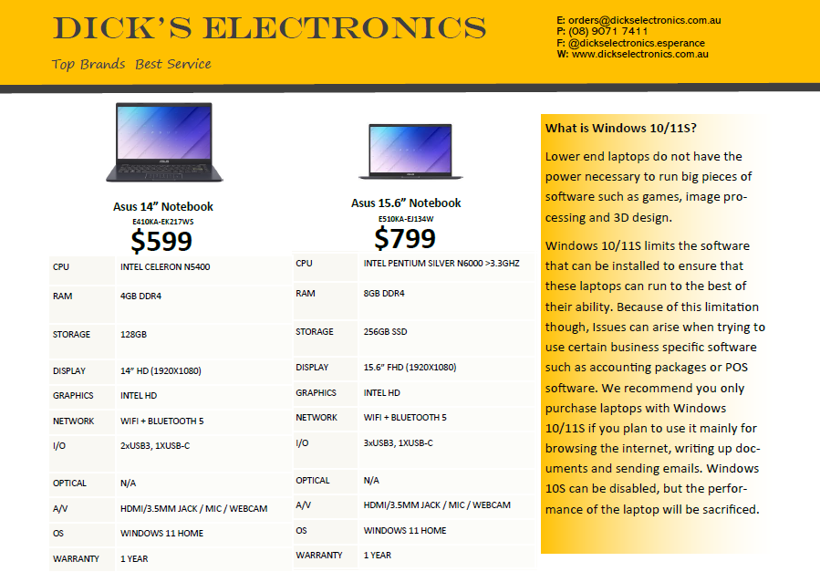
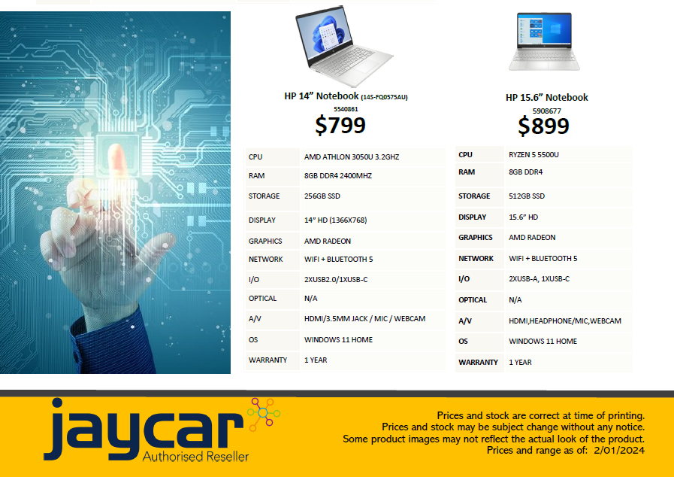

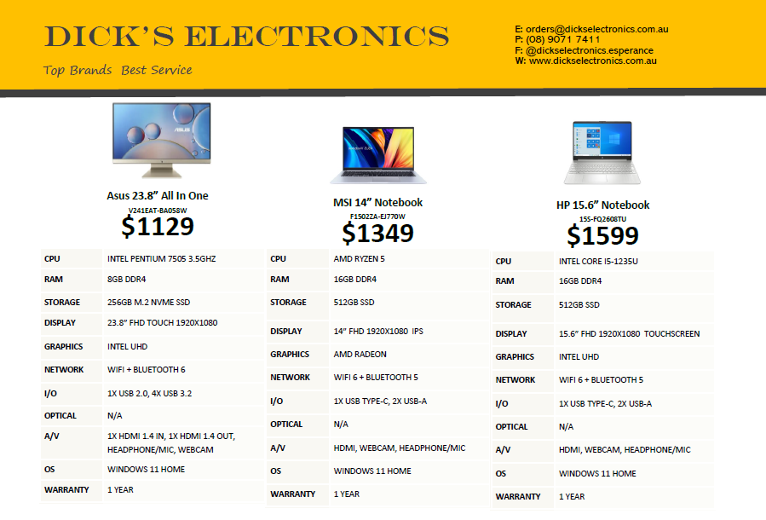
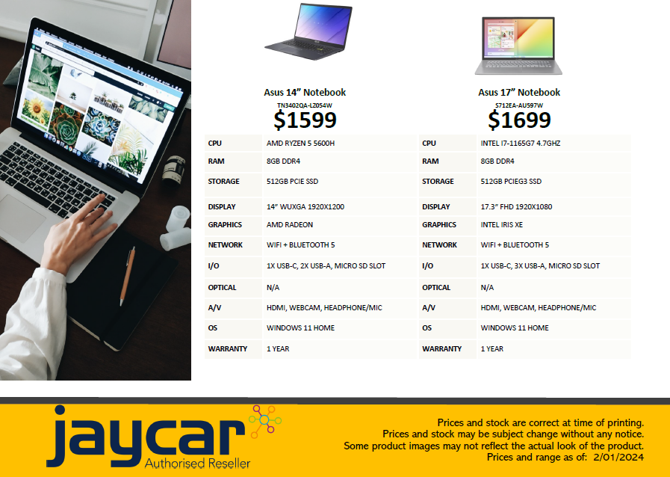

Attachment 4:

Emu’s Uniform Proposal

To the EHA,

The Emus Hockey Club would like to submit a proposal to the committee for a new uniform. The club’s current uniform is becoming outdated, and we are struggling to provide complete uniforms to new members due to missing sizes and numbers. The old uniforms also show sponsors that are no longer affiliated with the club, and we would like to update them with the new sponsors (please note that sponsors on the new uniform design are the old sponsors and are still yet to be changed).
The new uniform has been kept similar to the old uniform in colour and design, using red, green and white to set us apart from other teams. The major difference will be the skirt becoming entirely green, and the shirts using red as the main colour. Emus would also like to propose that we change our sock colour to red, as the green socks we currently use are hard to come by and the red will work better with the new uniform.
Emus also welcome any changes or suggestions that the committee has to offer.
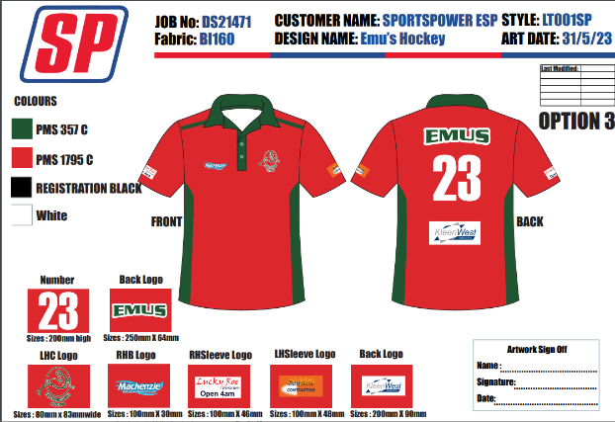
Shown below is the design of the new uniform with a photo of the old uniform as comparison.
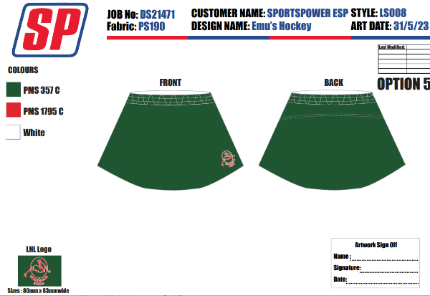

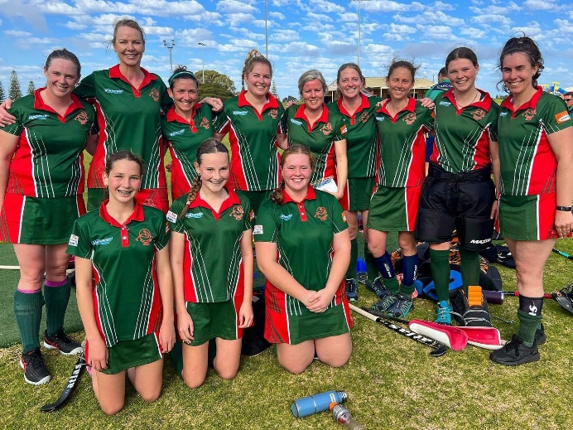

Kind regards,
Erin Stevens
Emus Hockey Club

