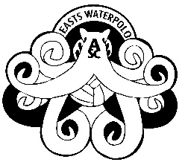

PARENT /GUARDIAN OR INDIVIDUAL CONSENT

- I agree to abide by the code of conduct of the Water Polo Australia and Easts Water Polo.
- I hereby release and indemnify Newcastle Water Polo and Easts Water Polo and its officers, servants and agents against all liability, actions, suits, claims, demands, proceedings, losses, damages, compensation, costs, charges and any expenses whatsoever in respect of any personal injury or any infringement disturbance or destruction of any rights of any person including myself and my son/daughter/ward arising directly or indirectly out of playing, training or spectating the game of Water Polo or any competition or tournament in the state of N.S.W.
- In the event of any accident or illness, I authorise the obtaining of such medical assistance on my behalf that my child may require. I also undertake to pay medical fees and /or cost of medication which may be incurred while my child participates in the sport of Water Polo.
- I agree to pay full registration prior to playing any game in this competition.
- I consent to information obtained as part of this registration process being kept on a Newcastle WPI database and passed on to WPNSW . This information can only be accessed by authorised personnel and used to process your registration application and to notify you of relevant events.
- I agree to allow Easts and Newcastle Water Polo to use, display, licence, sell and publish audio, audio visual and/or photographic recordings of me/my child, for the purpose of advertisement, promotion or otherwise.
Name ______________________________________
Player Name: ________________________________
Signature: ___________________________
Date: __________________

