REGISTRATIONS

All registrations are to be made via our club website Home - Dimboola Hockey Club - revolutioniseSPORT. This allows streamlining of payments and administration with Hockey Victoria.
Payments for registrations are all online. If online registrations and payments are difficult for you please contact Jennie (Club President), 0458 891 979 or Kate (Club Secretary) 0409 528 958.

Please note – All players must be registered and financial with Hockey Victoria and Hockey Australia prior to playing their first game of 2023 and highly advised when you start training. This ensures that you are insured in the event of accident or injury.

It is suggested that players also purchase Ambulance Cover.
In the event of injury, Hockey Victoria insurance may not fully cover emergency transport, please ensure you have your own Ambulance Victoria cover.

Fees
This year the Dimboola Hockey Club is offering players a 100% discount on DHC fees code: DHC2024Discount

AGE | DHC Fee | Hockey Victoria | Hockey Australia | Total
HookIn2Hockey + equipment pack | $35.00 | $35.00 | $22.81 | $92.81  Discounted - $57.81
HookIn2Hockey /  U12 Players | $35.00 | $35.00 | $77.81 | $147.81  Discounted - $57.81
Youth - Ages 13 – 18 | $50.00 | $53.00 | $45.31 | $148.31  Discounted - $98.31
Adult – 19yrs + | $60.00 | $70.00 | $57.31 | $187.31  Discounted - $127.31
Non-playing membership | $5.00 | $0.00 |  | $5.00

Executive Committee

Jennie Hauselberger President  0458 891 979 | Leigh Corbett  Vice President  0438 536 066 | Kate Ward  Secretary  0409 528 958 | Vicki Elliott  Treasurer  0407 503 823

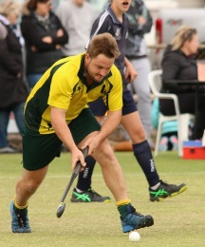
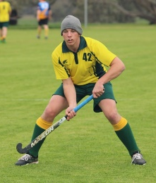
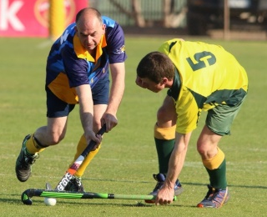
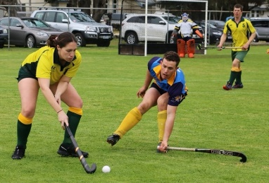
UNIFORM
Playing Shirts  (Available from DHC for loan) | Yellow & Green
Shorts | Bottle Green
Skorts | Bottle Green
Socks | Green with yellow stripe
Shin guards | (Some available from DHC for loan)
Shoes | Hockey runners or Runners  No cleated football shoes to be worn on turf field
Mouth guards | (Some available from DHC)
Sticks | (Some available from DHC for loan)
Facemasks | Provided by club for all U16 players
Goal Keeper kits | (Some available from DHC for loan)

We understand that starting a new sport can be overwhelming, and expensive, so please don’t hesitate to ask us about borrowing equipment or pieces of club uniform.

Please note all players must have appropriate shoes, shin guards and mouthguard to play games.

TRAINING

Training is held at the Dimboola Health and Fitness Centre, which is part of the Dimboola Memorial Secondary College. This is our home ground, and the only turf facility in the Wimmera. Access to the pitch is via School St.

Please see below for training days and times:

 | WEDNESDAY
4.30PM – 5.30PM | U12
5.00PM – 6.30PM | U16
6.00PM – 7.30PM | Women

We encourage top-age players to attend both their own team training as well as the group above training. This way they can familiarise themselves with their future team members and gain new skills and plays.

