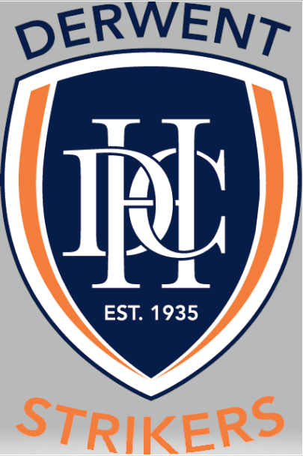

Life Membership Policy

TYPE OF POLICY | Participation
EFFECTIVE DATE | April 2021
POLICY OWNER | Derwent Hockey Club
POLICY CONTACT | Derwent Hockey Club - Secretary

REASON FOR POLICY
To articulate the level of contribution to the Derwent Hockey Club for an individual to be nominated as a Life Member.

POLICY STATEMENT
This policy is to articulate the process and requirements for the nomination, assessment, and appointment of Life Members of the Derwent Hockey Club. Life membership is generally conferred on a person who has rendered distinguished, loyal, outstanding, or special service to the Derwent Hockey Club in the role of Administrator, Athlete, Coach or Official.

SCOPE
This policy applies to all members of the Derwent Hockey Club.

DEFINITIONS
Sustained = 10 years or more
Key Committee Portfolio = President, Vice President, Secretary, Treasurer, Senior/Junior Coordinators (can be attained through combination of portfolios)

POLICY HISTORY
PARTICIPATION POLICY – NAME | VERSION | RELEASE DATE | AUTHOR
Life Membership | 1 | April 2021 | DHC Committee

BACKGROUND
On Friday 12 July 1935, the Derwent Hockey Club was formally constituted and played their first game the following day. At this time, the club was a male only domain. In 1977 Derwent Women were welcomed into the Southern Tasmania Women’s Hockey Association playing as a fully separate club.
During the 1980’s the male and female ‘clubs’ began discussing amalgamation, but it took until 1986 for this to officially occur and the two formed into what is known today as the Derwent Hockey Club.
Throughout the decades 26 individuals who provided outstanding service to the Derwent Hockey Club have been recognised with Life Membership.

Life Membership Policy
The purpose of this policy is to provide for the nomination, assessment, and appointment of Life Members of the Derwent Hockey Club. Life membership is generally conferred on a person who has rendered distinguished, loyal, outstanding, or special service to the Derwent Hockey Club in the role of Administrator, Athlete, Coach or Official.

Criteria for Life Membership
The following criteria are a guide of qualification of Life Membership, the ultimate decision to be made by unanimous vote of the elected committee. It is anticipated that the recipient will have contributed to the club in the following areas.

- Played at a high level over a sustained period
- Coached, either senior or junior grades over a sustained period
- Held a key Committee portfolio over a sustained period
- Personal contributions of undoubted and significant benefit to the Club (similar to the achievements of Matthew Wells – to be used as a yard stick)
- Long term involvement with the club in excess of ten (10) years. Does not include playing time
- Captain teams continuously over sustained period
- Manager teams continuously over sustained period
- General committee Member over sustained period
- Continuous umpiring role over sustained period

Minimum Qualification
The nominee must have an outstanding contribution in at least one of these areas and at least some contribution in two of the other three areas.

The above criteria are not automatic grounds for the granting of Life Membership. In determining the candidates’ nomination, consideration should be given to a comparison of existing Life Members achievements. Consideration should be given to existing Life Members comments and opinions. Life Membership should not be unduly withheld for worthy candidates. The person who is nominated is to be of good spirit and character.

Nomination Procedure
Any current club member can be nominated for Life Membership. Nominations with supporting evidence shall be submitted to the Secretary of the Derwent Hockey Club by email, no later than 1 August.
The Secretary is to advise the Executive Committee of all nominations and to convene a sub-committee consisting of a minimum of two existing life members and a member of the Executive to consider all nominations. Nominees must be considered individually on their personal attributes and achievements and not in comparison to other Life Members or other persons nominated.

Form of the Award
A Life member will be presented with:
- A Life membership pin
- A Life Membership plaque

Other Benefits of Life Membership
A Life Member shall be eligible to be elected to any position of the Committee. Whether or not elected to a Committee position, a Life Member shall have the full rights of membership of the club, including eligibility to attend and vote and Committee and General meetings of the club.
A Life Member will be invited to attend any formal club functions as a guest of the club.
The award of Life Membership to a club member will be published on the club’s website and Facebook pages and the recipient will be included in the club’s list of Life Members on the club’s home page.

