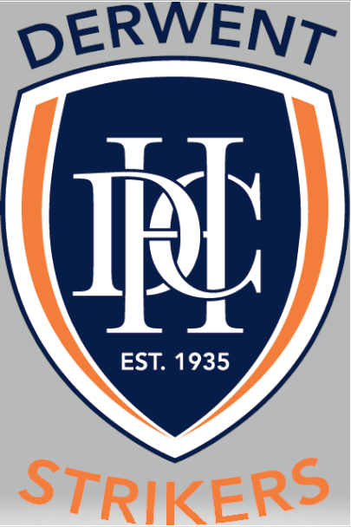

Code of Conduct

TYPE OF POLICY | Participation
EFFECTIVE DATE | April 2021
POLICY OWNER | Derwent Hockey Club
POLICY CONTACT | Derwent Hockey Club - Secretary

REASON FOR POLICY
To articulate the standards of behaviour that all participants in the game of hockey who are affiliated with the Derwent Hockey Club are to adhere to. The Code of Conduct enables you to:
- Conduct yourself honestly, transparently, and ethically.
- Uphold our values and protect our reputation.
- Understand what the Derwent Hockey Club expects from you.
- Comply with the standards that apply to our club.
- Understand where to go to for assistance.

POLICY STATEMENT
This policy is to create a culture that prioritises the safety, wellbeing, positive sportsmanship and enjoyment of all participants in the game of hockey who are affiliated with the Derwent Hockey Club.
Participants are encouraged and expected to:
- Show positive acts of sportsmanship, discouraging all instances of foul or illegal play, acts of violence, both on and off the field.
- Demonstrate the greatest levels of respects, protecting the rights, dignity and worth of every person regardless of gender, ability / disability, sexual orientation, cultural background or religion.
- Lead by positive example and condemn the use of recreational and performance enhancing drugs and doping practices, their use endangers the health of players and is contrary to the concept of fair play.
- Celebrate the ‘good news’ stories and understand that cyber-bullying which includes negative or demeaning comments, status posts, personal messages or emails, is deemed as a serious form of harassment.

SCOPE
This policy applies to all individuals affiliated with the Derwent Hockey Club who participate in the game of hockey.

DEFINITIONS
participant includes –
- all players
- coaches
- managers
- team officials
- match officials
- club officials
- volunteers
- parents / carers
- spectators

POLICY HISTORY
PARTICIPATION POLICY – NAME | VERSION | RELEASE DATE | AUTHOR
Code of Conduct | 1 | April 2021 | DHC Committee

BACKGROUND

Code of Conduct

Player Code of Conduct
- Always behave in a sporting manner to all players, officials and spectators.

- Do not make detrimental statements in respect of the performance of any other player, match officials or umpires.

- Always play by the rules and ensure that the game of hockey is not brought into disrepute by your actions.

- Do not engage in inappropriate and/or physical contact with players or officials during training, play or at any other time.

- Accept responsibility for all actions taken. Exercise reasonable care to prevent injury by ensuring that you play within the rules. Reasonable care consists of showing due diligence in abiding by the rules and adhering to the official’s decisions.

- Do not participate in the use of performance enhancing or illicit drugs. (Members are to comply with Hockey Australia and Hockey Tasmania’s corresponding policies on this topic.)

- Do not bet on the outcome or on any other aspect of a hockey match or competition.

- Do not try to achieve a contrived outcome to a match or competition, or otherwise improperly influence the outcome or any other aspect of a match or a competition.

- Do not show unnecessary obvious dissension, displeasure, or disapproval (by action or verbal abuse) towards a player, an umpire or match official because of his or her decision or generally.

- Do not racially or sexually vilify other players, officials or spectators.

- Respect the rights, dignity and worth of every person regardless of their gender, ability, cultural background or religion.

- Don’t do anything which adversely affects, reflects on or discredits the game of hockey, or any squad, team, competition, tournament, sponsor, including, but not limited to, any illegal act or any act of dishonesty or fraud.

- Refrain from using obscene, offensive or insulting language and/or making obscene gestures which may insult other players, officials or spectators.

Coaches, Managers, Club Officials Code of Behaviour
As a coach, manager or club official you must meet the following requirements about your conduct.
- Always treat all players with respect.

- Always behave in a sportsmanlike manner to other coaches, officials, players and spectators.

- Place the safety and welfare of the players above all else.

- Avoid situations that may lead to a conflict of interest.

- Be courteous, respectful and open to discussion and interaction.

- Make no detrimental statements in public in respect of the performance of any players, match officials or umpires.

- Promote a climate of mutual support amongst the players. Encourage players to respect one another and their worth within the team.

- Encourage and facilitate players’ independence and responsibility for their own behaviour, performance, decisions and actions.

- Determine, in consultation with the player, what information is confidential and respect that confidentiality.

- Avoid situations with your players that could be construed as compromising.

- Do not participate in the use performance enhancing or illicit drugs.

- Provide a safe environment for training and competition.\

- Recognise individual differences in players and cater to these as best you can.

- Make a commitment to providing a quality service to your players.

- Refrain from using obscene, offensive or insulting language and/or making obscene gestures which may insult players, officials or spectators.

- Respect the rights, dignity and worth of every person regardless of their gender, ability, cultural background or religion.

