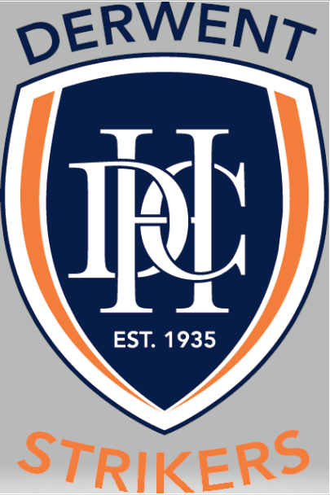

Team Coaches & Mangers Policy

TYPE OF POLICY | Participation
EFFECTIVE DATE | April 2021
POLICY OWNER | Derwent Hockey Club
POLICY CONTACT | Derwent Hockey Club - Secretary

REASON FOR POLICY
To articulate the obligations of each team coach and manager of Derwent Hockey Club teams.

POLICY STATEMENT
It is the aim of the Derwent Hockey Club to provide coaches and managers who maximise the enjoyment, development and in turn potential of the individual player within the structure of the team. It is paramount that this is achieved in a nurturing and positive environment that aims to provide the player and family with a positive social and hockey experience.

SCOPE
This policy applies to all coaches and managers of Derwent Hockey Club junior and senior teams.

DEFINITIONS
Spirit means trying ones best whilst displaying respect and tolerance for others. Including but not limited to umpires, opposition players / officials and of course our own team mates / officials.

POLICY HISTORY
PARTICIPATION POLICY – NAME | VERSION | RELEASE DATE | AUTHOR
Team Coaches & Mangers Policy | 1 | April 2021 | DHC Committee

BACKGROUND
Winning is not the primary objective of the Derwent Hockey Club. The club considers winning as a potential outcome that stems from the development of the individual within the structure and objectives of the team. Notwithstanding this it is accepted the club aims to field competitive sides with players who display a healthy competitive spirit.

Coaches & Managers Policy
It is the aim of the Derwent Hockey Club is that the Junior Coordinators will attempt to get the best available coaches to coach junior teams. We actively encourage coaches to undertake the Beginner (Level 1) and Development (Level 2) coaching accreditation. (see Hockey Ed web link http://www.hockey.org.au/index.php?id=72 for details.
Consideration will be given to coaches of junior teams in relation to fee relief for current senior and junior players at Derwent Hockey Club, or equivalent payment for non-playing members of the club. Anyone interested in coaching a team should contact the respective Coordinator.

Responsibilities of Coaches
Each person who has been appointed to act as a coach of a team of the Club shall:
- Be responsible for the development and improvement of the general fitness, game skills and knowledge of the rules of the game of hockey of each player in the team;
- Abide by any Club policies regarding player selection and development.
- Attend all coaching sessions unless sick, injured or otherwise exempted by the relevant Coordinator.
- Attend all matches played by the team for which they have been appointed to coach;
- Advise relevant Coordinator if sickness or injury or any other event appears likely to prevent participation in coaching sessions or matches, and such advice should be given as much in advance as possible in view of the time which may be required to organise a substitute coach for the coaching session or the match, as the case may be;
- Ensure that appropriate training is undertaken in relation to coaching techniques and all relevant developments and changes in the game of hockey.

The Club expects that every coach will:
- Encourage every player under his control to play fairly and by the rules of the game of hockey (see Code of Conduct);
- Apply himself / herself fully in discharging his/her coaching responsibilities, acknowledging that a coach must also encourage appropriate moral behaviour as well as impart knowledge appropriate to the game of hockey (see Code of Conduct);
- Support, encourage and motivate all members of the team equally both on and off the field.

Team Manager’s Responsibilities
- Ensure all players are registered, available and know where they are playing prior to each round.
- Ensure team is organised on match day – they know the positions they are playing; bench is being rotated, players in proper uniform, etc.
- Ensure players are complying with Derwent Hockey Club Code of Conduct

