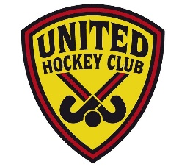
C.R. UNITED HOCKEY CLUB INC.

ILLEGAL DRUG POLICY ALL MEMBERS

C.R. United does not allow the use, distribution or selling of illegal drugs by any club member or visitor within the club’s jurisdiction.
This policy reflects our club’s commitment to protecting the health, safety and well-being of all persons associated with the club and all persons in attendance at club activities.
This policy refers to illegal drugs only, which is defined as “a substance that is not permitted to be taken or used according to state or national laws, such as cannabis, amphetamines, ecstasy, cocaine, heroin and a range of new psycho-active substances known as synthetic drugs”.
This policy applies whenever the individual is taking part in activities under the club’s jurisdiction, including our club facilities, games, training and events.
Private behaviour of members is not included in this policy, as the club cannot be responsible for the behaviour of its members outside our club’s jurisdiction; however, this policy will apply whenever an individual is wearing any official C.R. United uniform or apparel.

