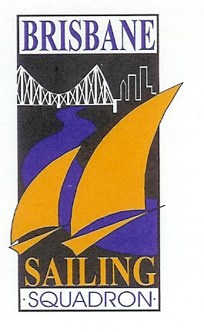Brisbane Sailing Squadron Inc. (BSS)
Hall Booking Request Form

Type of Function:
Preferred Date/s:
Start & Finish Time:
Expected Number of Guests:
Name of Person Making Booking:
Phone Number (Mobile Preferred):
Email Address:

By completing and returning this form you are agreeing to the below Hall Hire terms and conditions.
Terms & Conditions
Deposit & Bond:
A deposit of $250.00 will be required to confirm the booking. The deposit will only be refunded where a booking is cancelled greater than 30 days before the booked date. The deposit will also be held as a bond. The deposit/bond will usually be refunded within 7 days of the function, provided there is no damage to property of BSS; terms, conditions and responsibilities have been met; and no complaints are received from local residents or the police. BSS reserves the right to deduct a fair amount from the bond refund for any property repairs deemed to be the fault of the hirer or for any additional cleaning required.

Hall Hire Fees:

Standard evening function - $650.00 + $150 cleaning fee
Wedding - $1,000.00 + $150 cleaning fee

For Saturday functions during the club’s licensed hours, $30 per hour for the provision of a RSA certified club representative.

We also have a range of additional hire items per attached listing to assist you to stage your function , without the hassle of organising pick-up or delivery. Any additional hire items your request will be waiting for you when you arrive at the hall.

The hall hire fee, plus fees for any additional hire items you request, is payable 7 days prior to your function.

Responsible Person:

BSS requires that at least one member of the hiring party, and who will be attending the function, takes on the role of ‘Responsible Person’. In addition to the terms and conditions included in this form, this person is responsible for managing compliance with our noise, fire and emergency evacuation, alcohol and security requirements. The Responsible Person will also oversee the Covid-Safe guidelines for the event. Full details of these requirements and the responsibilities of this role are listed in the ‘Responsible Person Form’ available on the BSS website https://www.revolutionise.com.au/bss/.

General Noise:

Hall hirers must meet all noise regulations imposed on functions at the BSS hall by the Brisbane City Council through our Entertainment Venue License. Full details of the noise regulations are outlined in the ‘Responsible Person Form’.

The responsible person will monitor and ensure the following occurs:
- No live music on the deck – must be contained inside the hall
- No music of any type on the deck after 10pm
- All music (live or recorded) to cease at 11:30pm
- Function to cease by 12am
- Departing guests to be monitored and reminded to keep noise to a level which does not disturb neighbours

Cleaning:

Due to additional Covid cleaning requirements, a $150 cleaning fee is payable and BSS will take responsibility for the post-function cleaning of the hall and toilets. The hirer is responsible for :
- Chairs and tables should be left out and wiped for any spillages.
- Hall floor swept for any significant debris.
- Food preparation areas should be wiped and left clean to catering standards.
- Food preparation/storage devices cleaned appropriately.
- Deck swept, if required for any significant debris.
- All rubbish placed in the industrial bin provided.

This must be completed by 9:30 am the following day or as otherwise agreed. We arrange for our cleaner to come in prior to your function, so everything will be clean and tidy ready for your set up.

Decorations:

Decorations may be used, but must be affixed in a way that does not damage timber or paintwork and must be fully removed after the function. Additional lighting must comply with electrical safety standards.

Other Restrictions:

There will be a designated smoking area, which must be used. No drinks or glassware are to be taken downstairs.

I agree with the above terms and conditions, and wish to request a hall booking: YES / NO

BSS Office Use Only

Booking Accepted (date): …………………………….. Deposit Received & Booking Confirmed (date): ……………………………..

Deposit/Bond Refunded (date): ……………………………..

