Reflections on the 2018 Worlds at Gavle, Sweden
by Michael Leydon
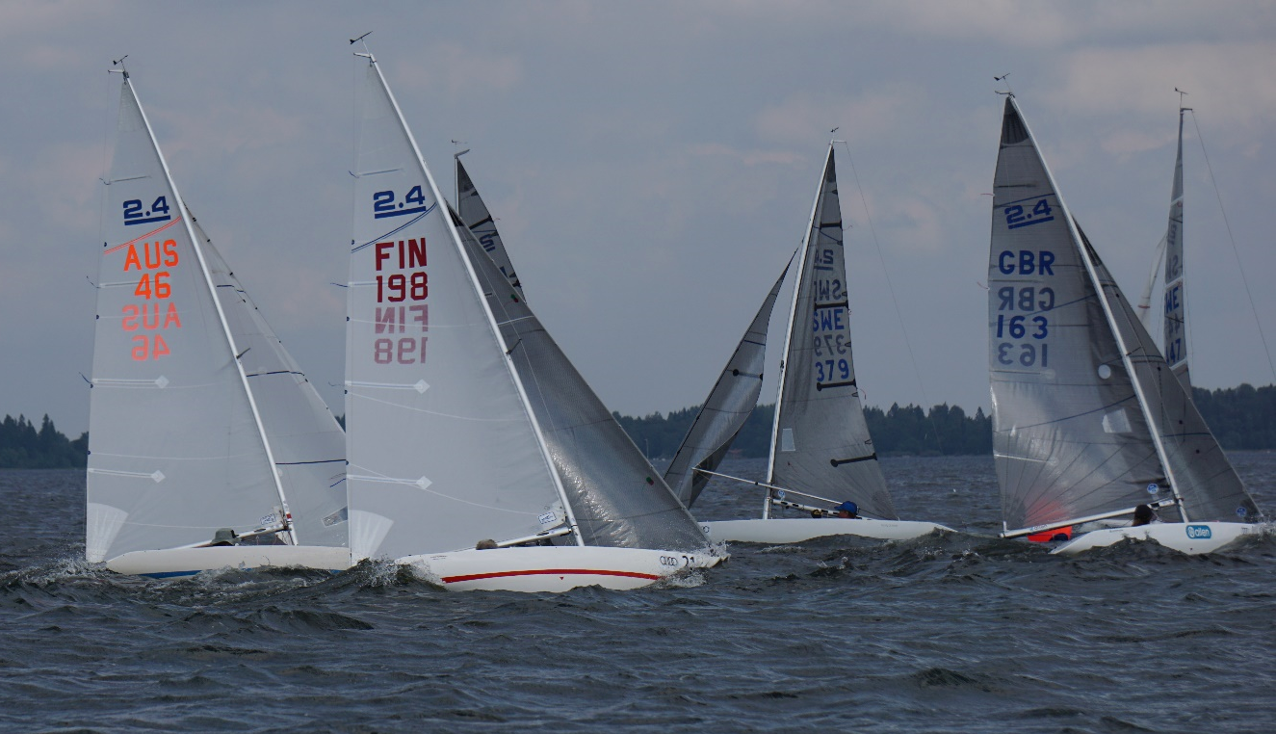
72 attended this regatta where we sailed in a full range of conditions - from the very light (under 5 knots) to strong winds (20-25+ knots). The club is situated in a little bay with a small marina that provided berthing. The clubhouse had a very homely feeling. There was a marquee erected at the end of a restaurant to provide the main function area. Due to the light weather, we lost 2 races so we only sailed the practice race and the first 2 days on the outer course; moving to the inside course for the final 2 days. We sailed 10 out of the 12 championships races, just enough to give us 2 drops. The races were sailed on 2 of the 3 courses. The first used for the light weather took over 75 minutes to sail to the course, race and then sail another 75 minutes home. We finished the regatta (Day 3 and 4), on the closest course which was about 10 minutes from the club. The courses were what I consider ‘long courses’ with the target time of 50 minutes which was usually exceeded, so I enjoyed that aspect very much.
An analysis of the results is very interesting, for me anyway, as it is quite revealing. Congratulations must go to Stellan, Megan and Marko and all the other competitors including Sue, Peter, Troy and (me).
Out of the 11 races sailed, boats with Neb Sails, using factory masts, won 8 races, over all conditions. North Sweden (Stellan) won 2 races using a factory mast and Megan using North’s, England, (Megan’s design now available) won 1, on a SuperSpar.
Three different skippers, using Neb’s and the factory mast were Rikard, (2 worlds and the practice race), Marko (4 world’s) and Janne (1 world’s).
To be fair, Stellan won in the light and moderate races and in the 9th race, which was 20+ knots he sat on Megan and had no need to win the race, just give Megan a bad one. Having done enough, he withdrew from the last race. The day started in quite light conditions and we were waiting around for the breeze to fill in. When it came, it was a good 15 knots and slowly built to over 25 by the finish of the last race. Those of us who had light weather sails on had no opportunity to change sails, so a lot of people had the wrong sails up for the conditions. There were a lot of blown out light weather sails by the end of the regatta! I saw 7.2 knots on the final run to the finish and on the hoon home I saw 9.3 knots. Over all, I was happy with my charter boat - a very honest boat. Peter had troubles with his electric pump and Sue had a good boat with some vang mast fitting issue.
I am really happy with my regatta, keeping up with Stellan and Megan at times. Still more to learn….
Catch you all soon,
Michael.

